**PART II: Network**

1. **Explorer: Explore latest blockchain data.**

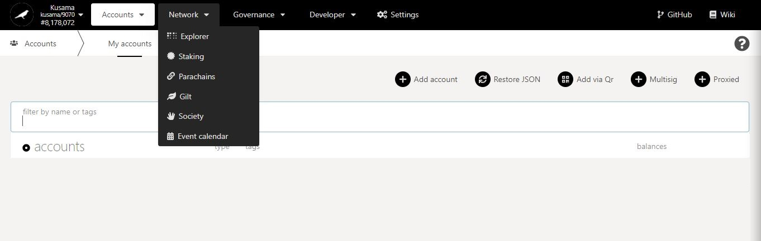

* 1. **View blockchain information.**

**Search** block hashes or block numbers.

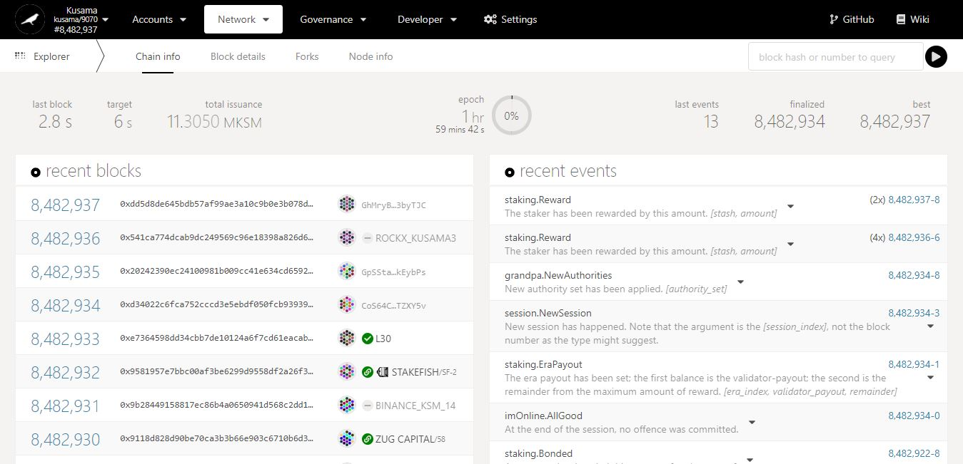

Recent **block hashes**.

Recent **block numbers**.

Key information on blockchain: **time elapsed since last block, targeted block time, total KSM supply, epoch countdown, blocks’ statistics.**

Recent **block validators**.

Overview of transactions/operations **included in recent blocks**.

* 1. **View block details.**

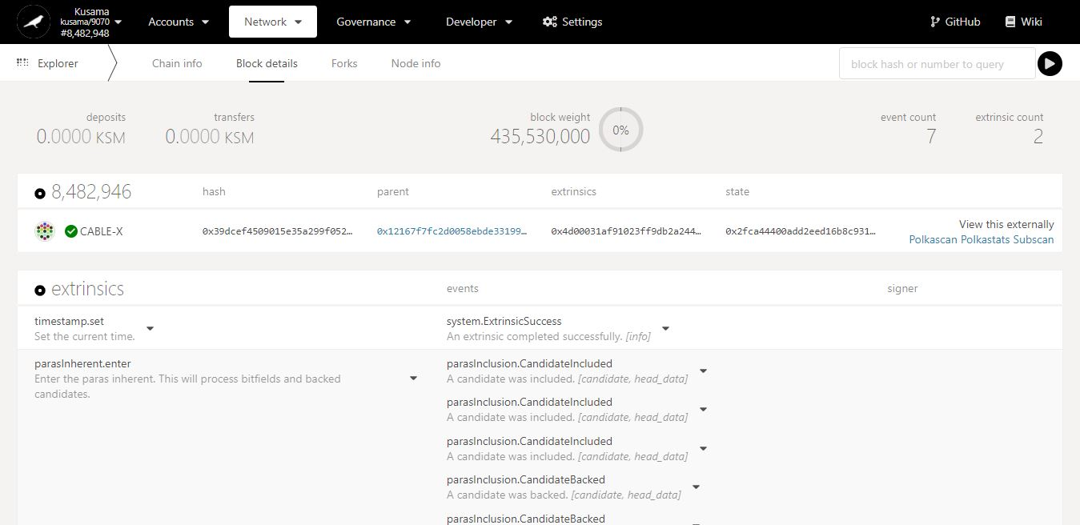

Key information on current block: **amounts transferred, block weight, and number of transactions.**

Extrinsics & Events in detail:

An event isa piece of data **from within the blockchain** (ex: issue a reward payout from my validator).

An extrinsic isa piece of data **from the outside world** (ex: claim a reward payout for my stash).

Overview of transactions/operations **included in this block**. Note: Click on the dropdown arrow to view each individual transaction/operation in greater detail.

* 1. **Monitor blockchain forks.**

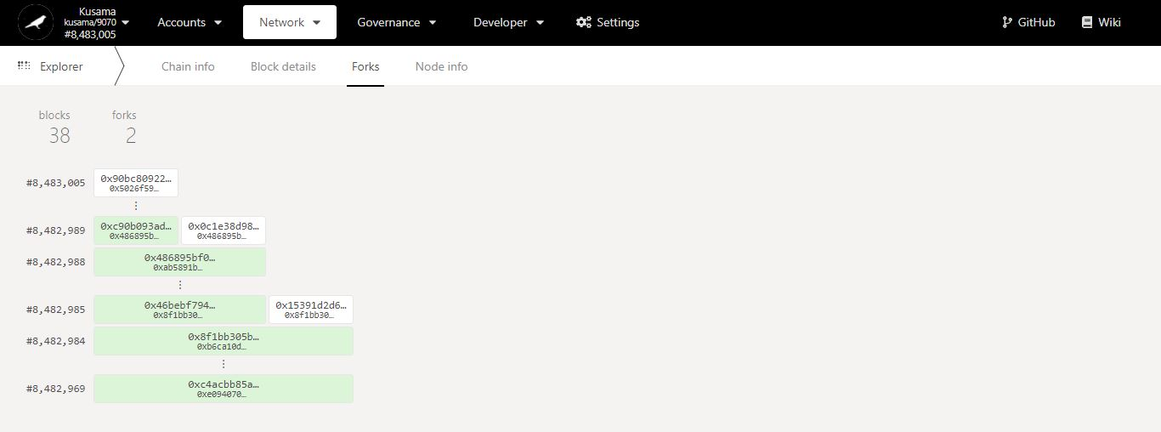

Key information on forks: **number of blocks captured, and number of forks encountered since monitoring started.**

Last **propagated** block number and block hash **(white colour)** captured by this node since monitoring started.

Last **finalised** block number and block hash **(green colour)** captured by this node since monitoring started.

**2nd fork.**

**1st fork.**

* 1. **Monitor blockchain nodes information.**

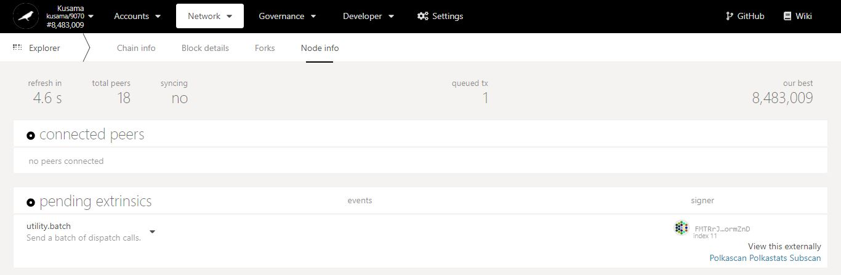

Key information on current node: **countdown to refresh, peer nodes, sync status.**

Latest block number **captured.**

**Sender(s)** of the transaction(s) in queue**.**

**Nature** of the transaction(s) in queue.

Number of **transaction(s)** in queue**.**

Number of node(s) **connected to this node.**

1. **Staking: Explore staking-related operations.**



**Basic information on technical words** used in the STAKING section.

* 1. **View general staking information.**

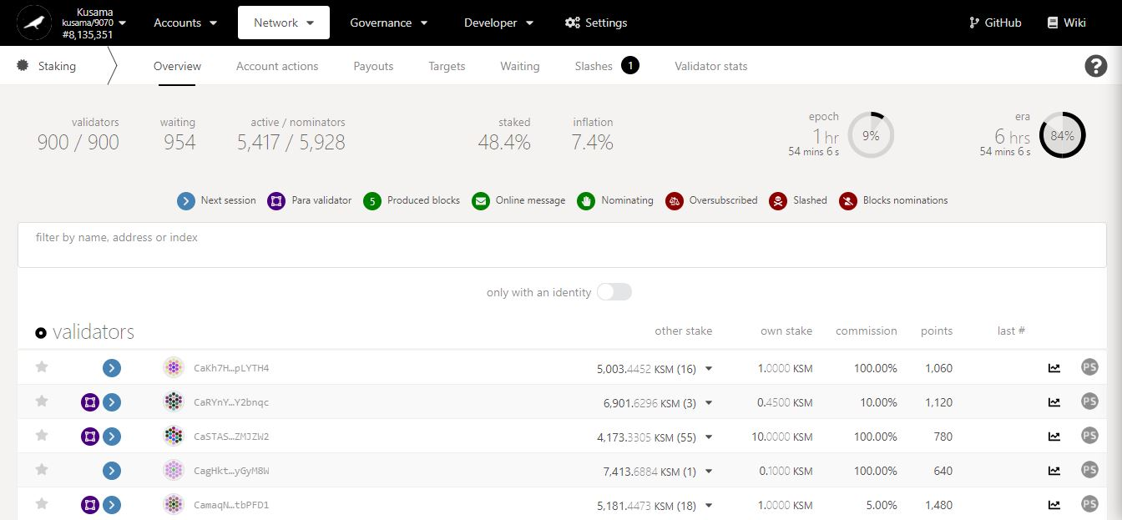

Key information on **validators, nominators and staking statistics.**

Countdown to the **inclusion of new nominators into the list of rewardees**.

Summary of **validators’ balances, commissions, and performance.**

Addresses of **currently elected validators**.

**NEVER SEND YOUR KSM TO A VALIDATOR’S ADDRESS!**

* 1. **Manage account nominations:**
* **Set nominators.**

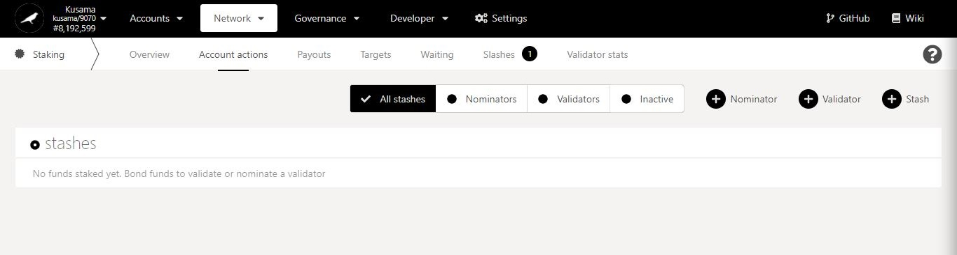

1. Click **Nominator**.

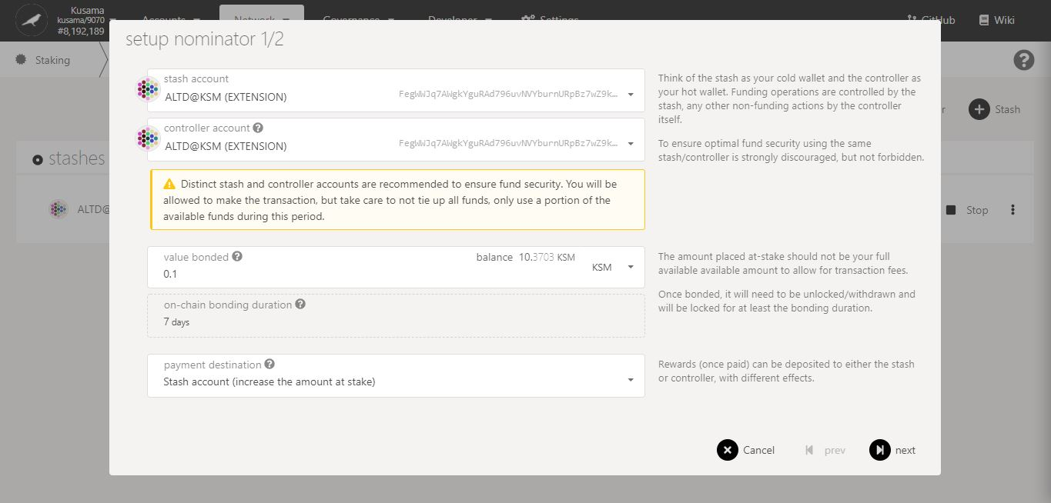

2. Follow **on-screen instructions** carefully.

3. Double-check **warning messages.**

**[Troubleshooting 1/4]**

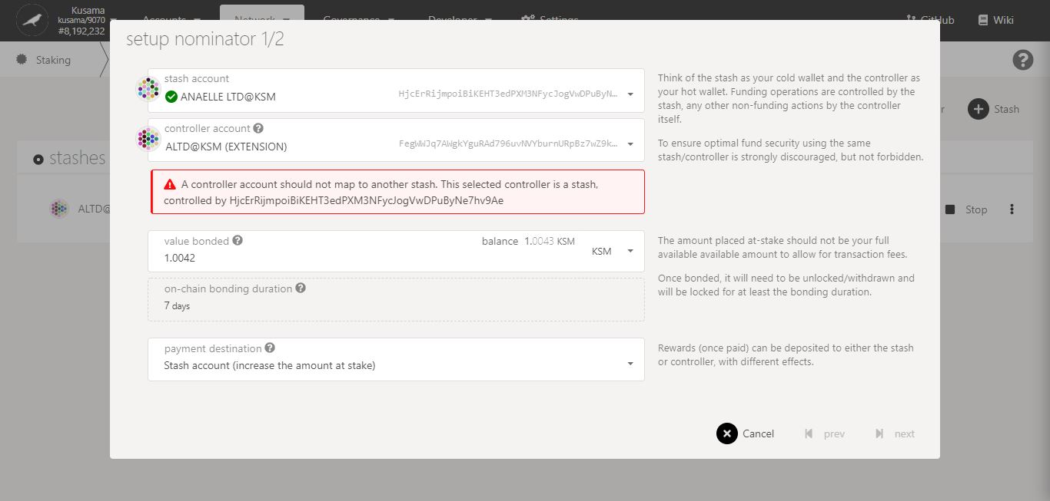

Issue:

You are trying to **use an existing stash as a controller for your new stash**!

Possible solution(s):

- Make the new stash and its controller identical.

- Create a new Polkadot-JS account and set it as the controller to the new stash.

Double-check **error messages.**

**[Troubleshooting 2/4]**

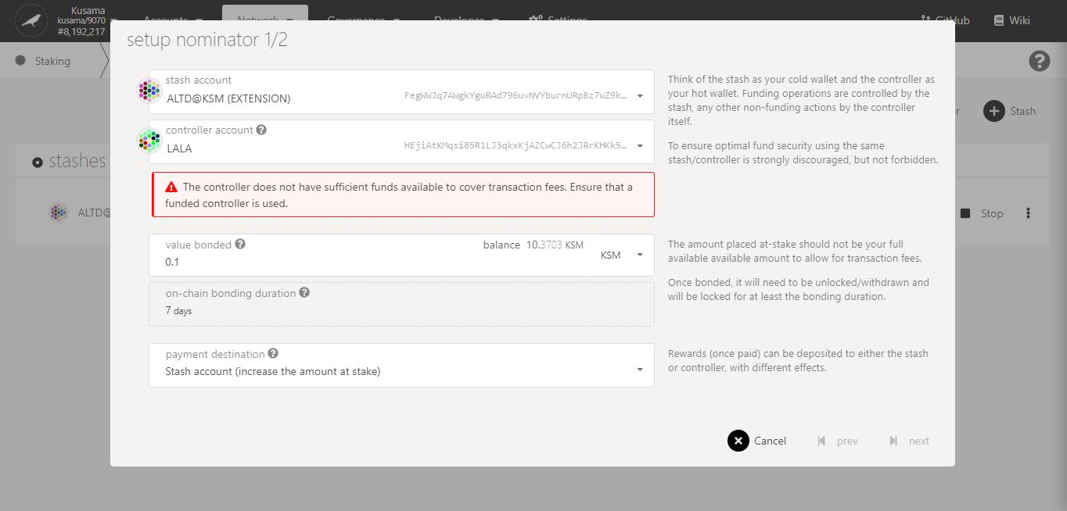

Issue:

Your chosen controller **does not have enough KSM to pay for the transaction fees!**

Possible solution(s):

- Add more funds to your chosen controller’s balance.

- Use a different controller that has a sufficient KSM balance.

Double-check **error messages.**

**[Troubleshooting 3/4]**

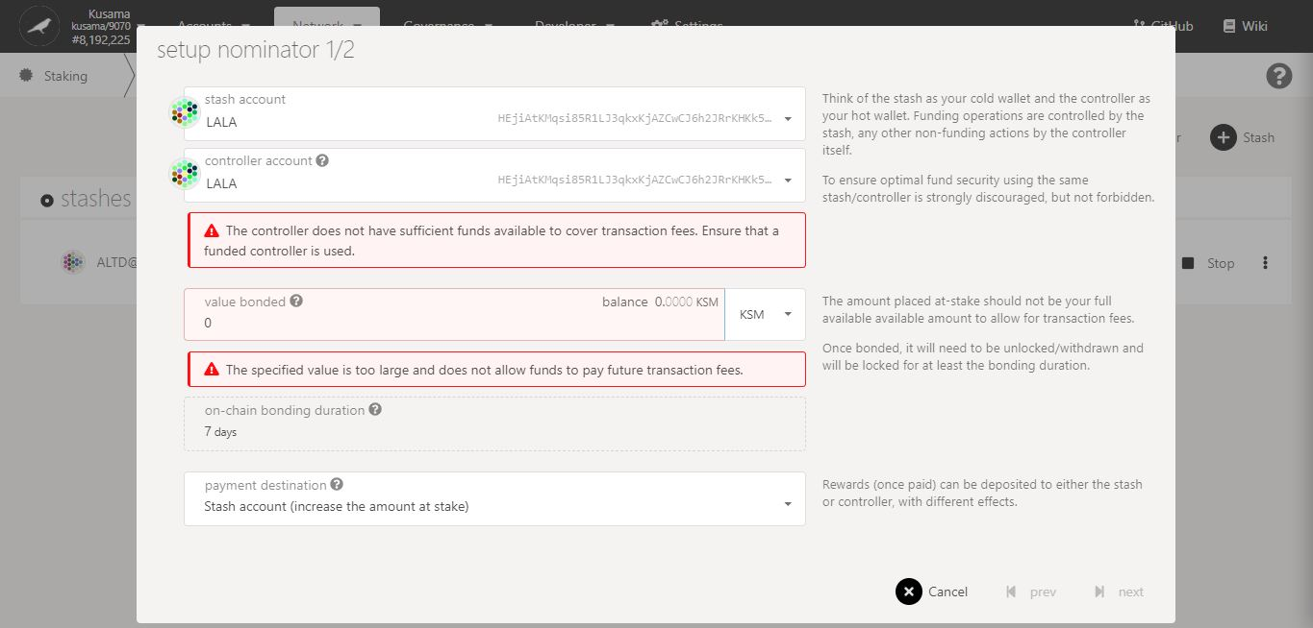

Issue:

Your stash and controller **do not have enough KSM to bond for the nominations and to pay for the transaction fees**!

Possible solution(s):

- Add more funds to your stash balance and controller balances. Note: A minimum of 0.1KSM is needed to nominate.

- Bond more funds into a pre-existing stash that has a some spare KSM.

Double-check **error messages.**

**[Troubleshooting 4/4]**

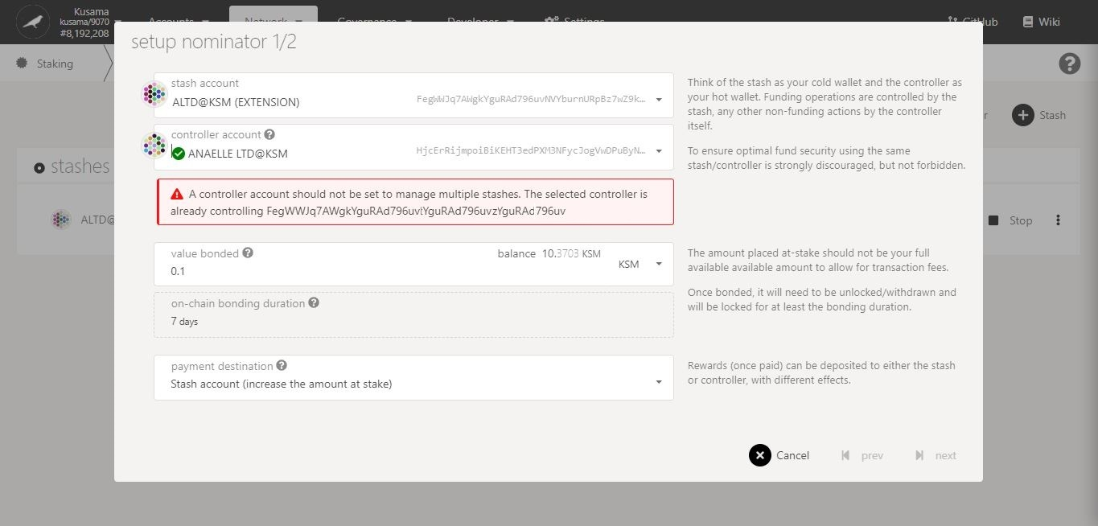

Issue:

You are trying to **use one controller for many stashes**!

Possible solution(s):

- Make the new stash and its controller identical.

- Create a new Polkadot-JS account and set it as the controller to the new stash.

Double-check **error messages.**

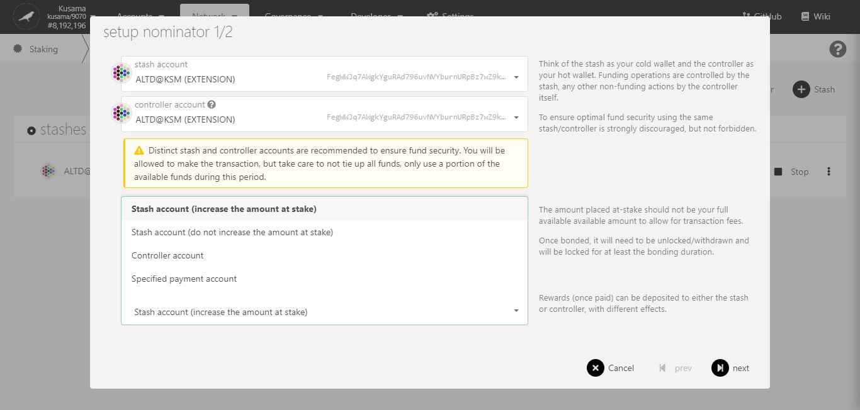

4. Select **one** option for **receiving reward payouts**.

5. Click on **Next** to continue the procedure.

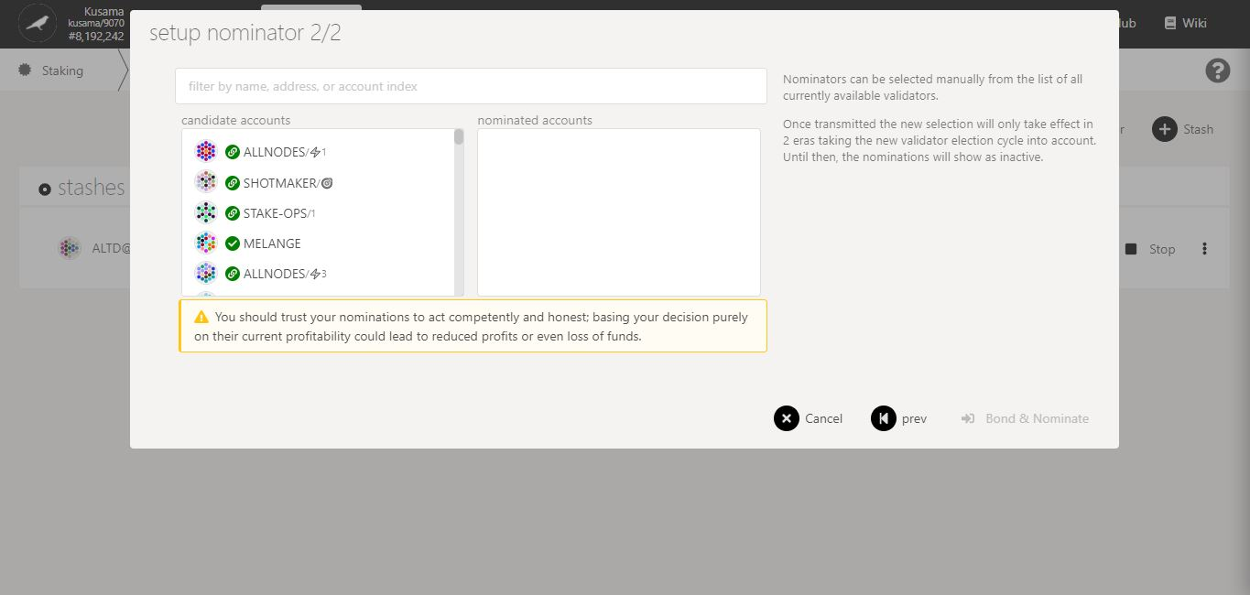

6. Follow the **new instructions** carefully.

7. Double-check **warning messages.**

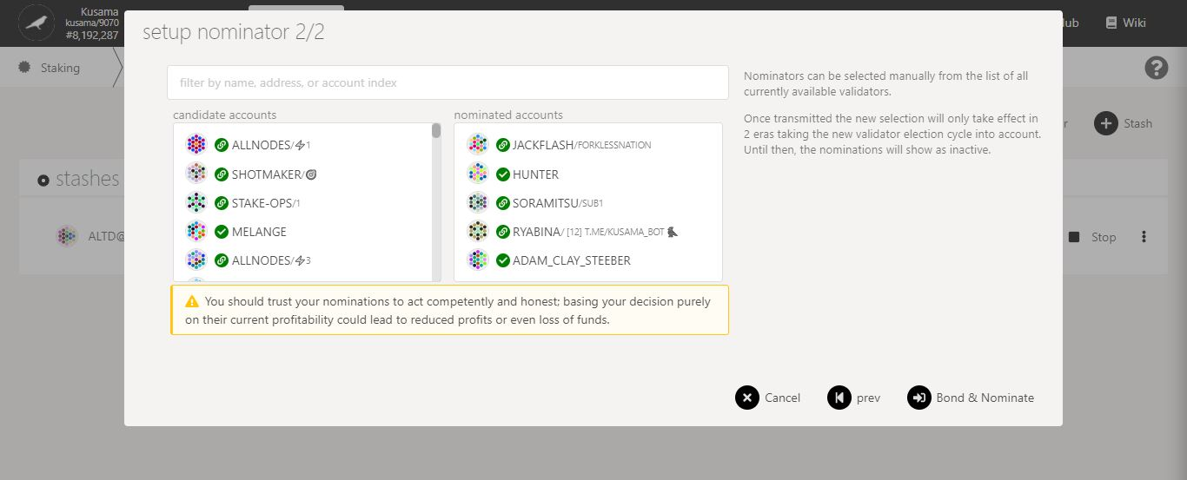

8. Click on **10-16** **validators’ names or addresses** to add them to **your selection**.

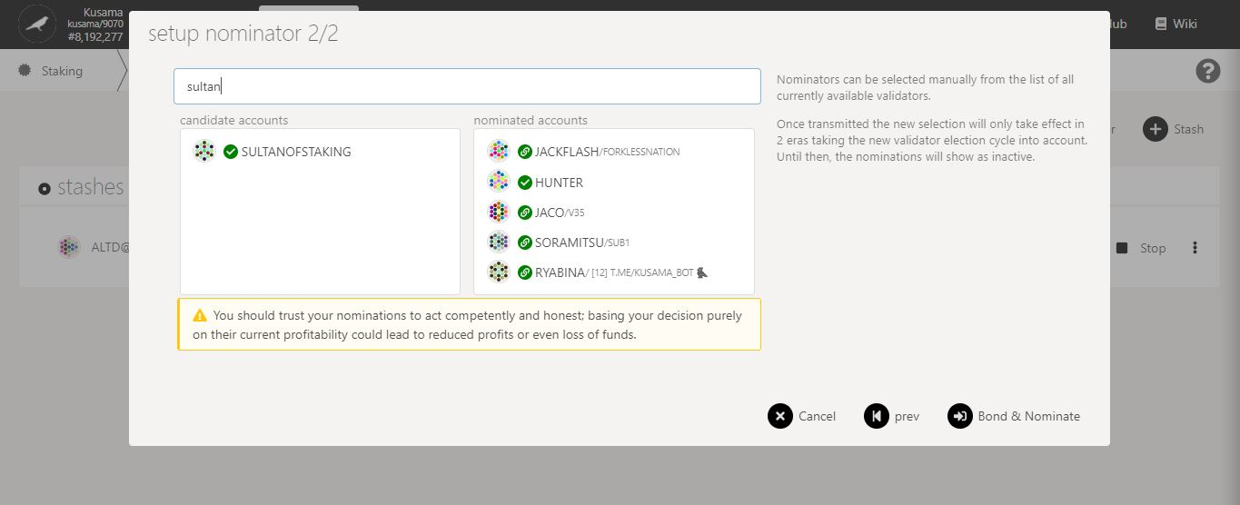

9. You can **search for your favourite validator** to speed up this process.

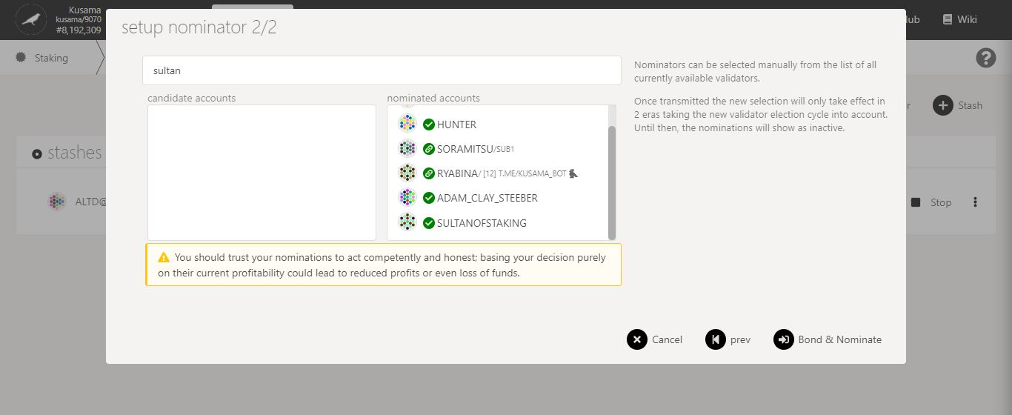

11. Click on **Bond & nominate** to continue the procedure.

10. Double-check your **selection of validators.**

**Nature** of the transaction.

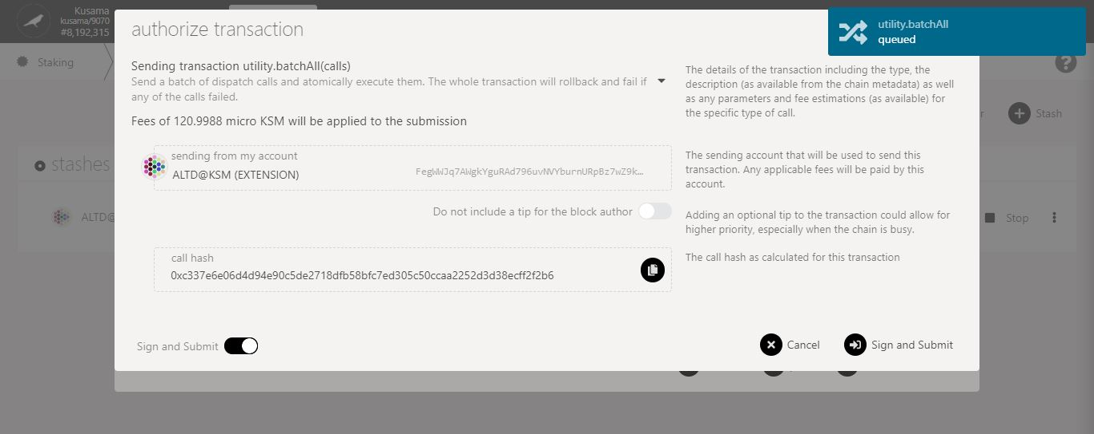

**More validators**

= more nominations

= **higher transaction fees**.

12. Follow the **final instructions** carefully.

13. Click on **Sign & submit** to continue the procedure.

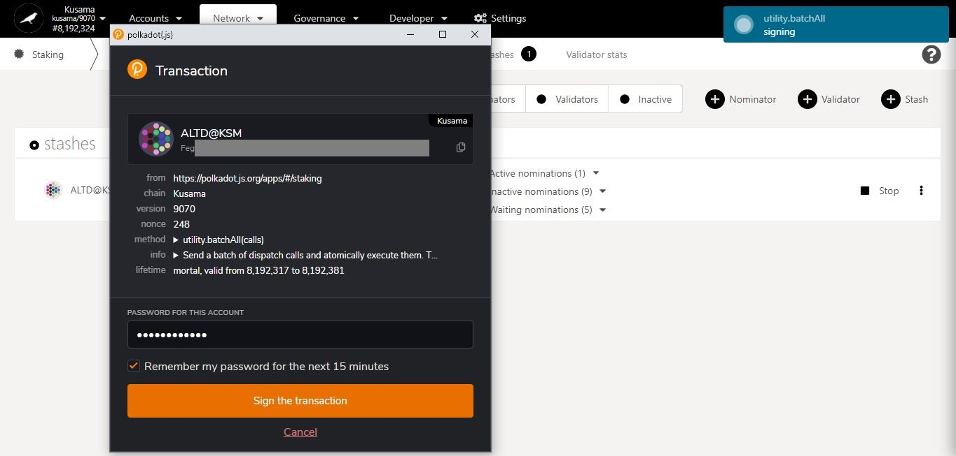

15. Click on **Sign the transaction** to complete the procedure.

14. Enter **your account’s password** and tick the box to **remember your password, if necessary**.

**Summary** of the transaction sent via the Polkadot-JS extension.

**Progress** of the transaction.

* **Add stashes.**

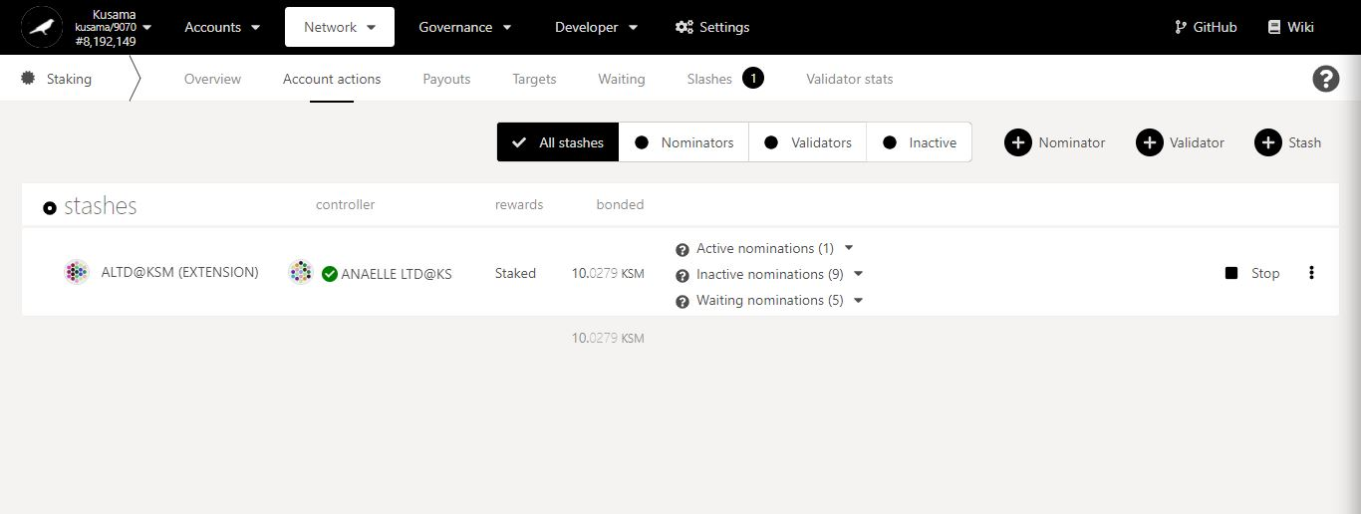

1. Click **Stash**.

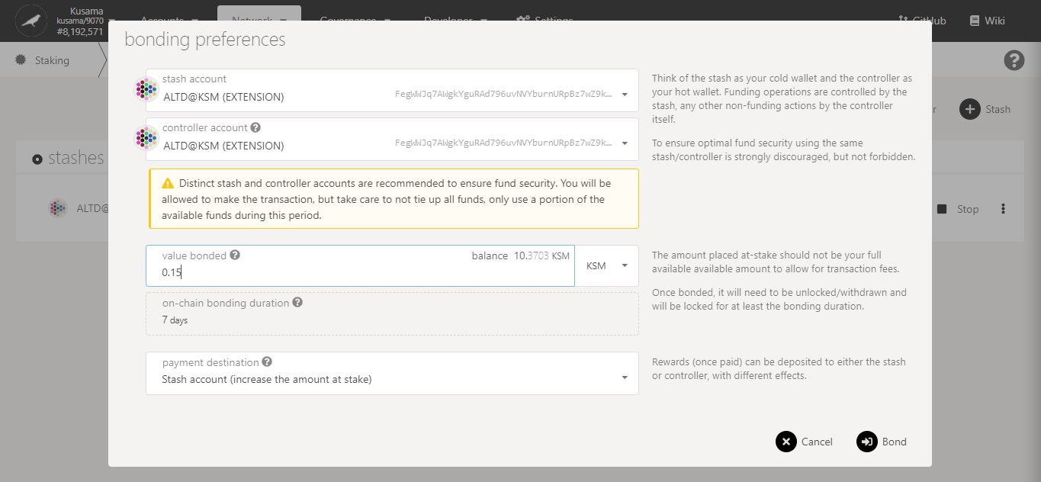

4. Click on **Bond** to continue the procedure.

3. Double-check **warning messages.**

2. Follow **on-screen instructions** carefully.

**Nature** of the transaction.

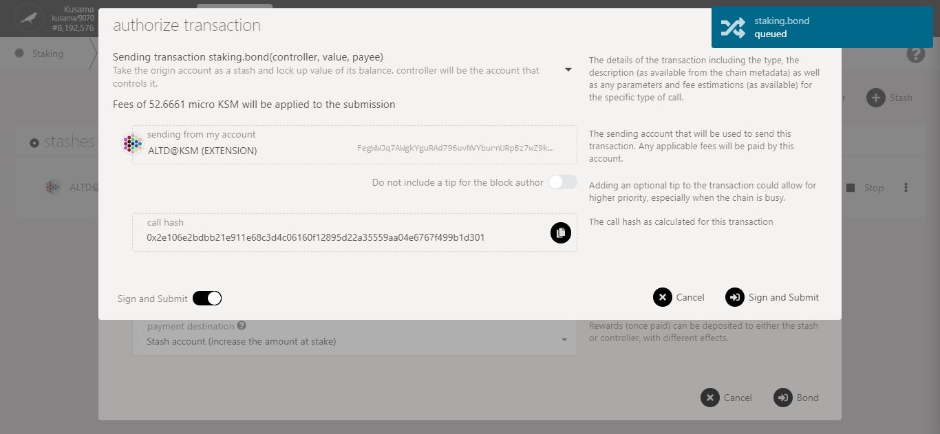

5. Check the **transaction fees**.

6. Click on **Sign & submit** to continue the procedure.

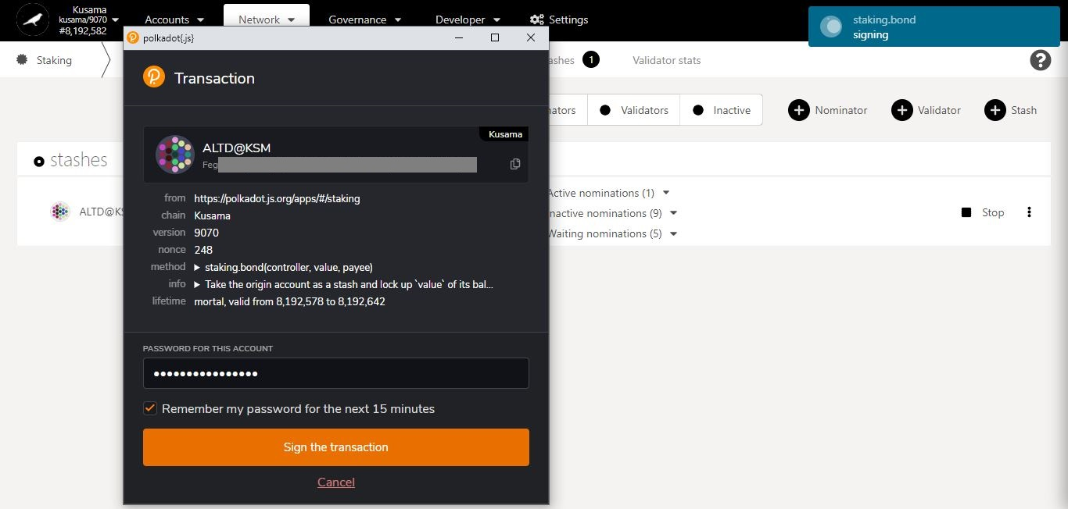

**Summary** of the transaction sent via the Polkadot-JS extension.

8. Click on **Sign the transaction** to complete the procedure.

7. Enter **your account’s password** and tick the box to **remember your password, if necessary**.

**Progress** of the transaction.

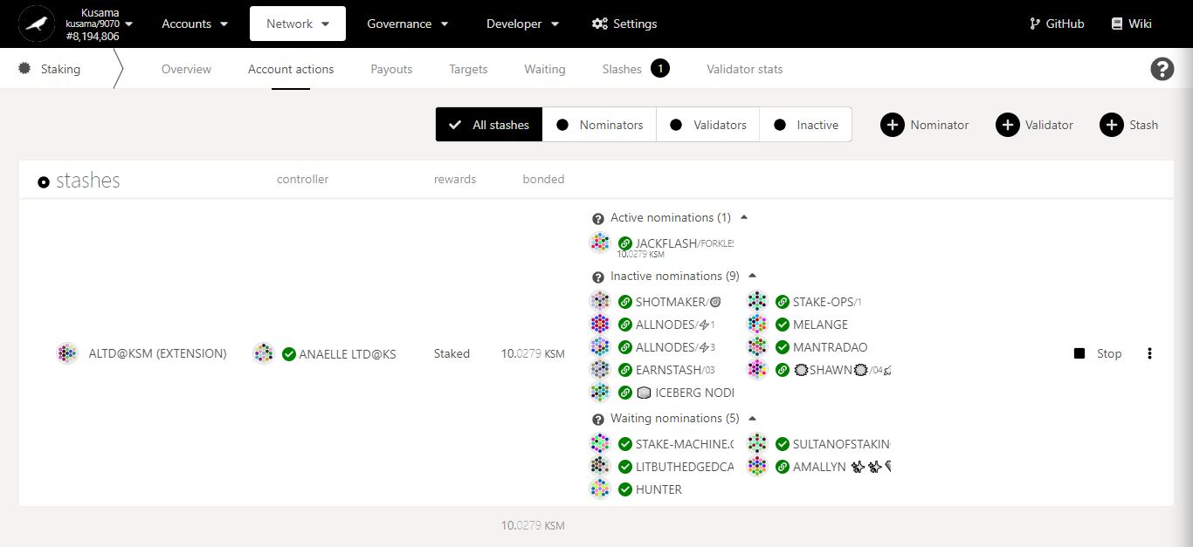

Staking summary:

**Staked:** Total balance of KSM bonded/locked into nominations (includes reward payouts made into the stash).

**Active nominations:** Nominated validator that is in the active set and making reward payments for the current era.

**Inactive nominations:** Nominated validators that are in the active set but not making reward payments for the current era.

**Waiting nominations:** Nominations waiting to be included in the active set or in the list of rewardees.

Stop all **nomination activities associated with this stash.**

Name of **the controller**.

It is used to **set nominees for bonded KSM on behalf of a stash**.

Name of **the stash**.

It is used to **bond KSM for nominations and set a controller.**

It can be used **to compound reward payouts.**

**View** all the stashes associated to your existing accounts.

* **Bond more funds.**



1. Click on the 3 vertical dots to view **Staking settings**.

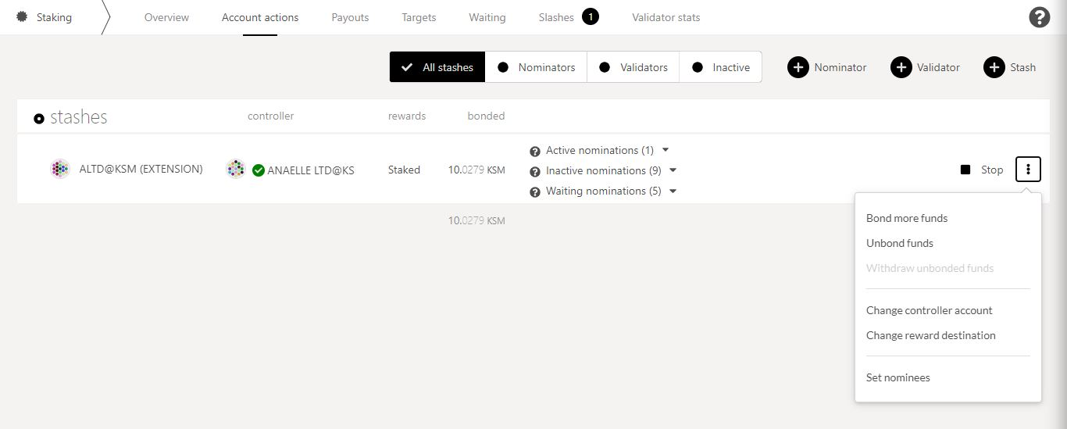

2. Click on **Bond more funds** to increase the amount of KSM you are staking.

3. Follow **on-screen instructions** carefully.

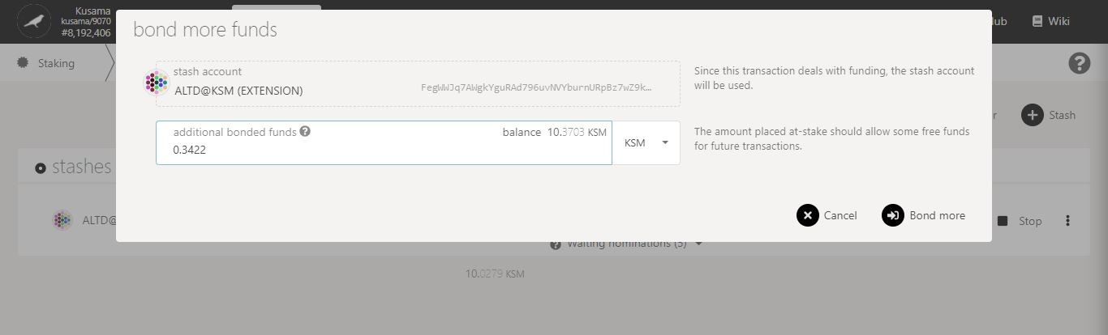

4. Click on **Bond more** to continue the procedure.

**Nature** of the transaction.

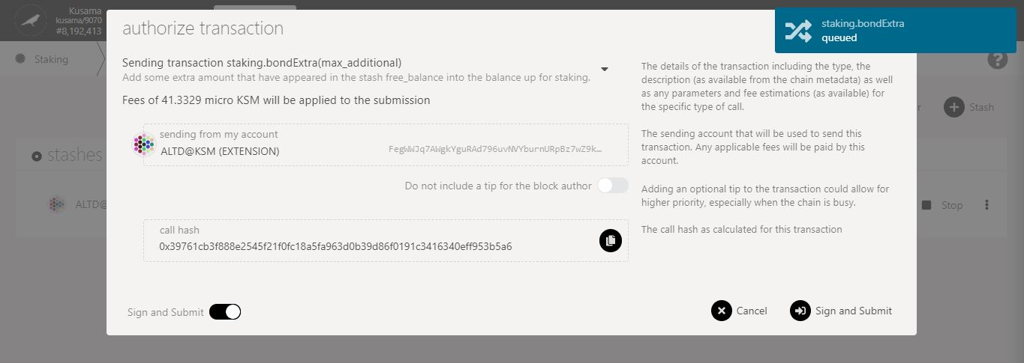

5. Check the **transaction fees**.

6. Click on **Sign & submit** to continue the procedure.

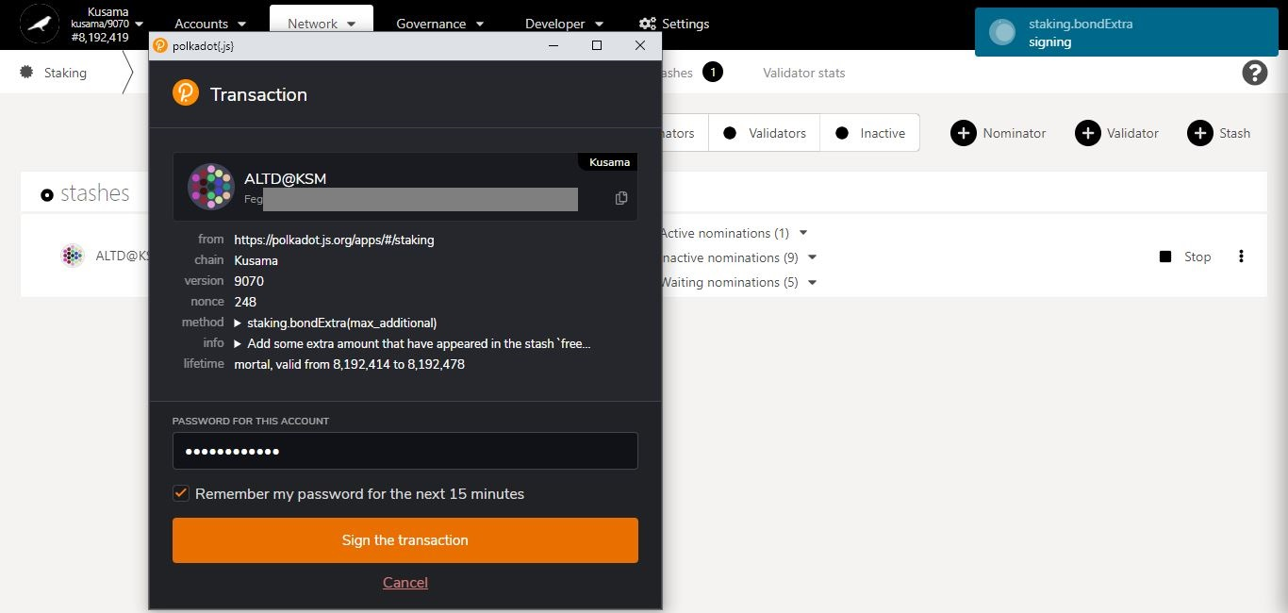

**Summary** of the transaction sent via the Polkadot-JS extension.

8. Click on **Sign the transaction** to complete the procedure.

7. Enter **your account’s password** and tick the box to **remember your password, if necessary**.

**Progress** of the transaction.

* **Unbond funds.**



1. Click on the 3 vertical dots to view **Staking settings**.



2. Click on **Unbond funds** to decrease the amount of KSM you are staking.

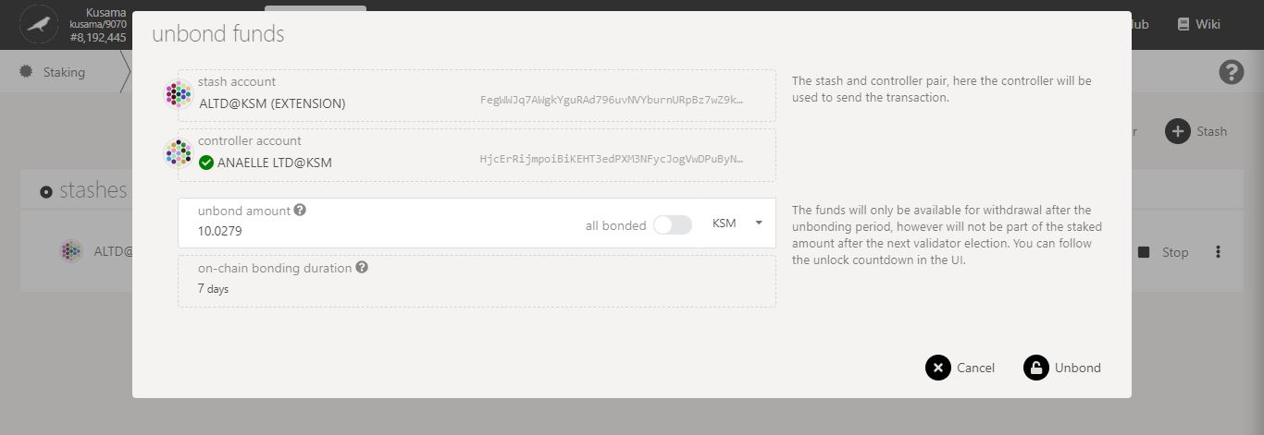

4. Click on **Unbond** to continue the procedure.

3. Follow **on-screen instructions** carefully.

**Nature** of the transaction.

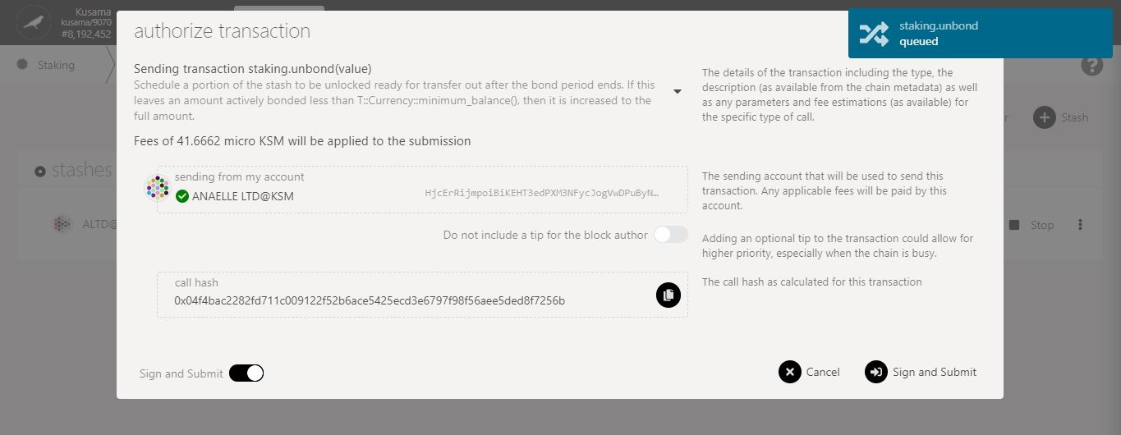

5. Check the **transaction fees**.

6. Click on **Sign & submit** to continue the procedure.

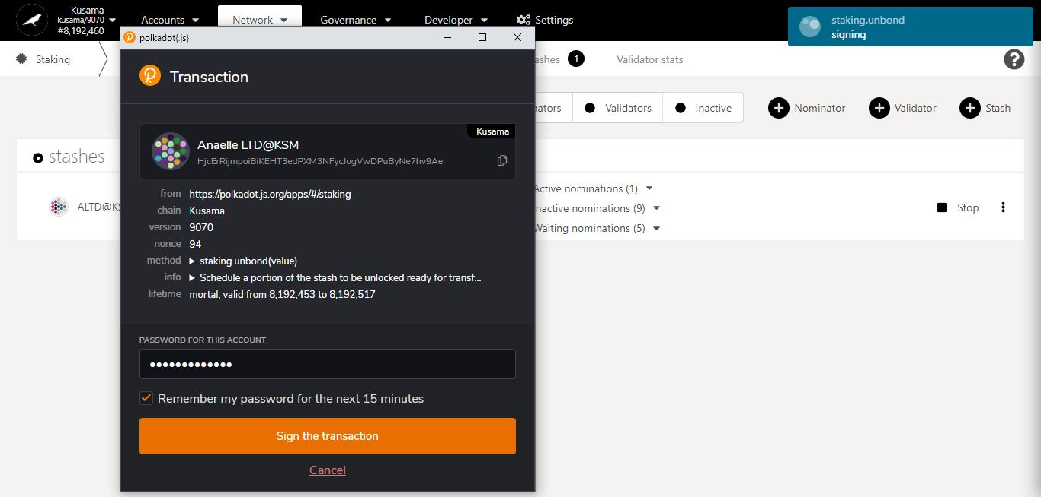

8. Click on **Sign the transaction** to complete the first part of the unbonding procedure.

**Summary** of the transaction sent via the Polkadot-JS extension.

7. Enter **your account’s password** and tick the box to **remember your password, if necessary**.

**Progress** of the transaction.

9. **Your funds have now entered an unbonding period!** **You will need to wait for 7 days before you can complete the procedure.**

10. **After 7 days, your unbonded funds are now ready to be withdrawn!**

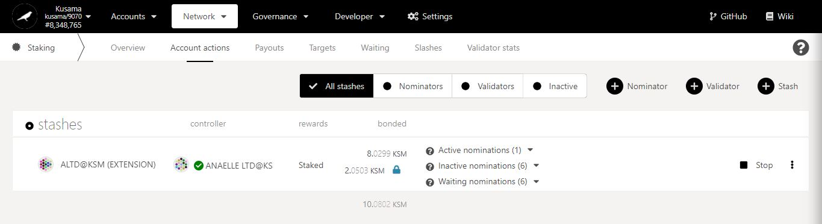

11. Click on the **padlock icon** to start the second part of the unbonding procedure.

**Nature** of the transaction.

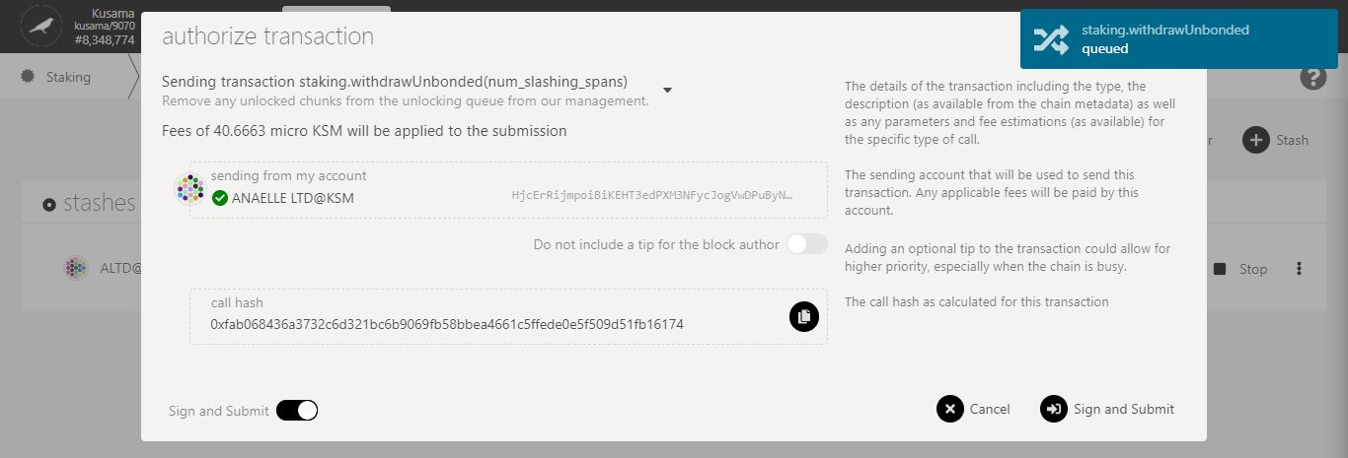

13. Click on **Sign & submit** to continue the procedure.

12. Check the **transaction fees**.

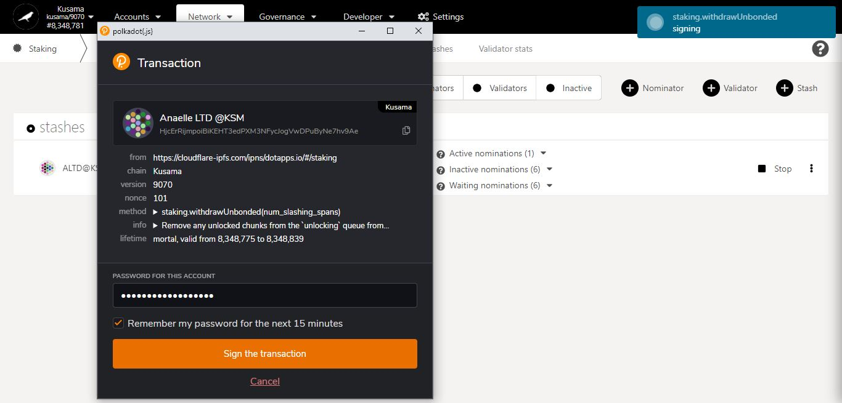

15. Click on **Sign the transaction** to complete the unbonding procedure.

**Summary** of the transaction sent via the Polkadot-JS extension.

14. Enter **your account’s password** and tick the box to **remember your password, if necessary**.

**Progress** of the transaction.

* **Change controller account.**



1. Click on the 3 vertical dots to view **Staking settings**.



2. Click on **Change controller account** to set a new controller for this stash.

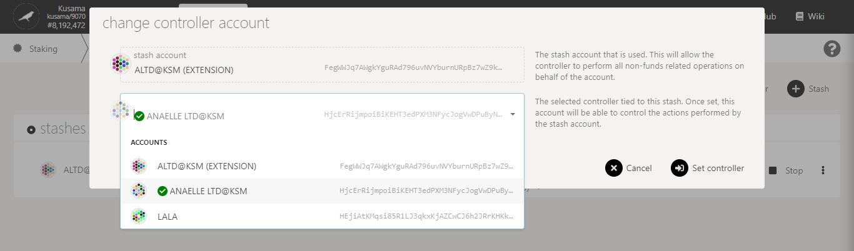

3. Follow **on-screen instructions** carefully.

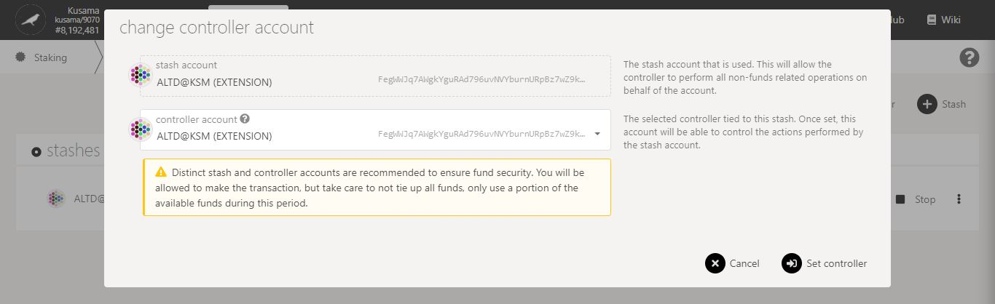

4. Double-check **warning messages.**

5. Click on **Set controller** to continue the procedure.

**Nature** of the transaction.

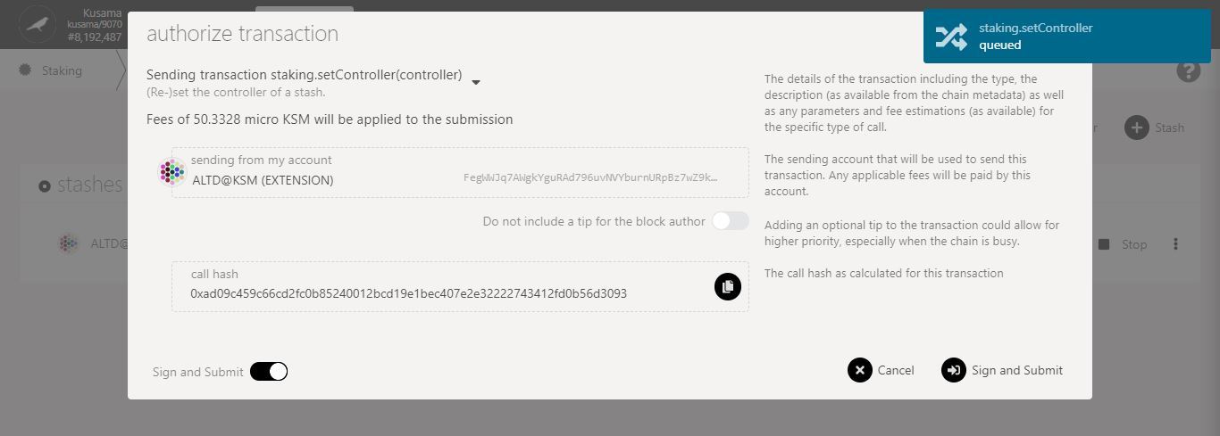

6. Check the **transaction fees**.

7. Click on **Sign & submit** to continue the procedure.

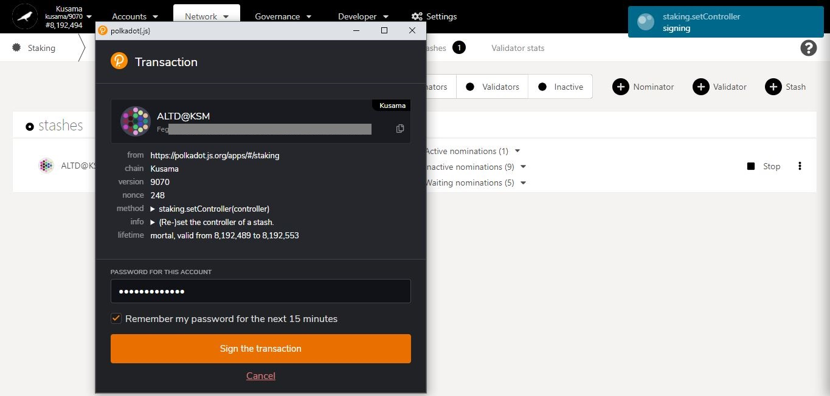

**Summary** of the transaction sent via the Polkadot-JS extension.

9. Click on **Sign the transaction** to complete the procedure.

8. Enter **your account’s password** and tick the box to **remember your password, if necessary**.

**Progress** of the transaction.

* **Change reward destination.**



1. Click on the 3 vertical dots to view **Staking settings**.



2. Click on **Change reward destination** to reset how/where your reward payouts are made.

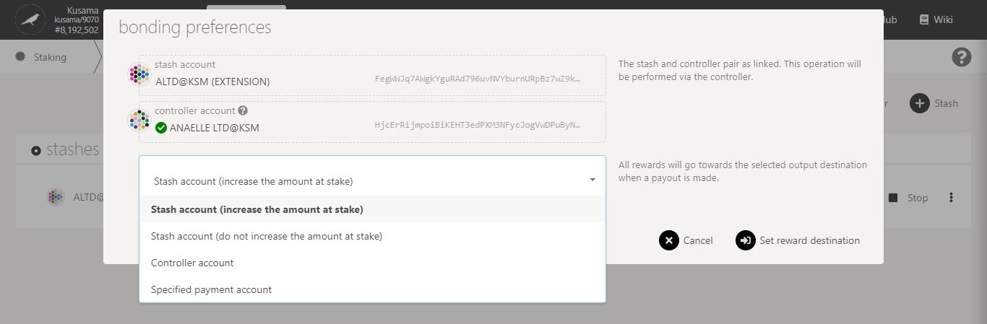

3. Follow **on-screen instructions** carefully.

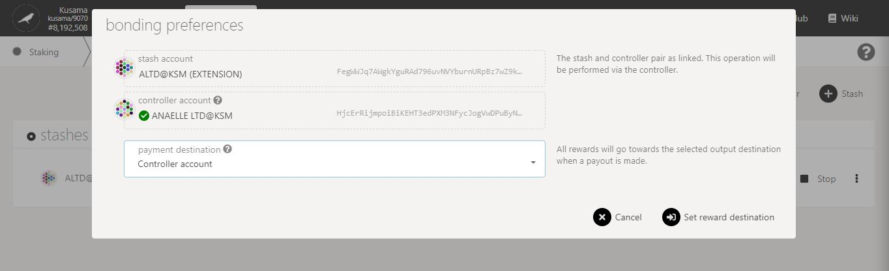

4. Click on **Set reward destination** to continue the procedure.

**Nature** of the transaction.

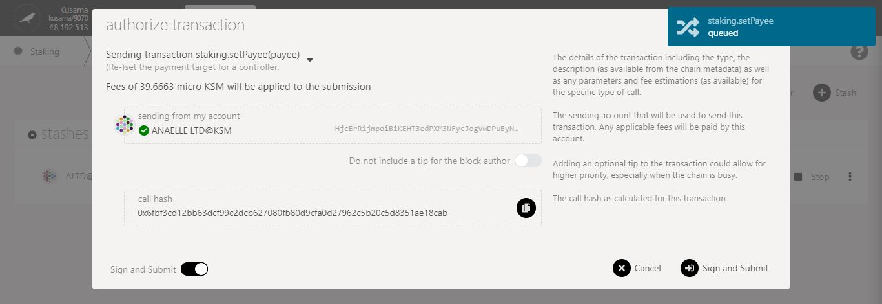

5. Check the **transaction fees**.

6. Click on **Sign & submit** to continue the procedure.

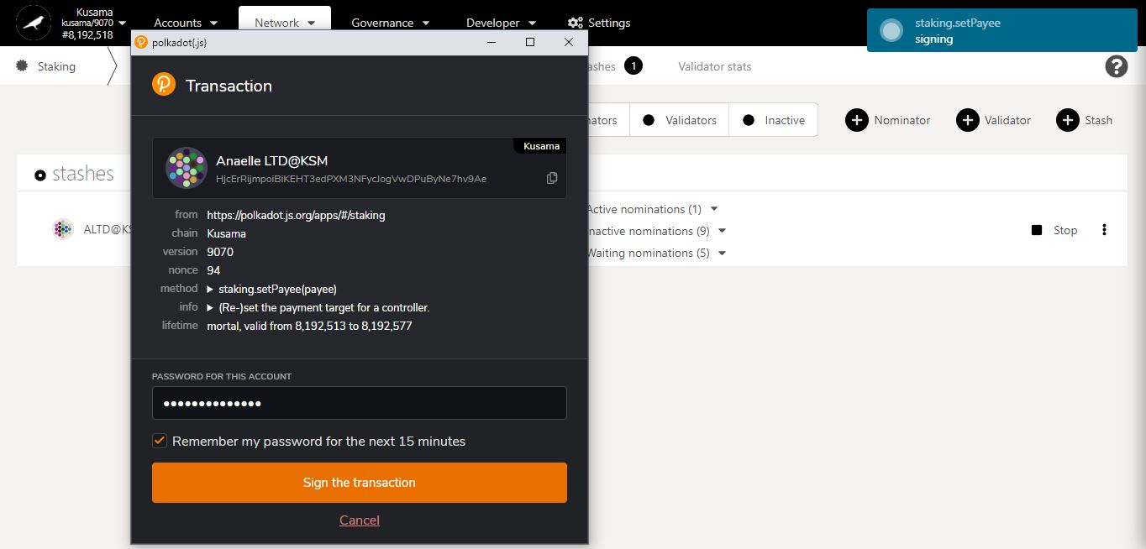

**Summary** of the transaction sent via the Polkadot-JS extension.

8. Click on **Sign the transaction** to complete the procedure.

**Progress** of the transaction.

7. Enter **your account’s password** and tick the box to **remember your password, if necessary**.

* **Set nominees.**



1. Click on the 3 vertical dots to view **Staking settings**.



2. Click on **Set nominees** to change your current selection of validators.

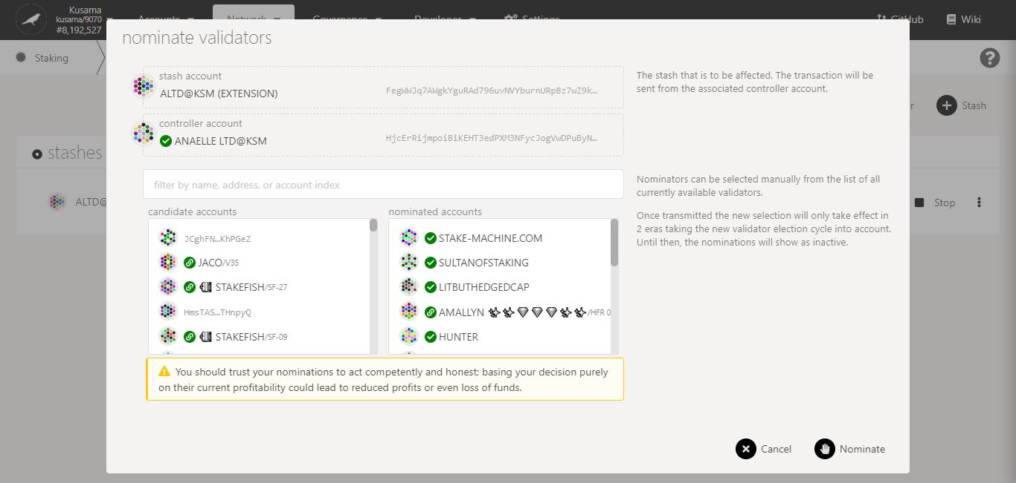

4. Click on **10-16** **validators’ names or addresses** to add them to **your selection**.

5. Double-check **warning messages.**

3. Follow the **new instructions** carefully.

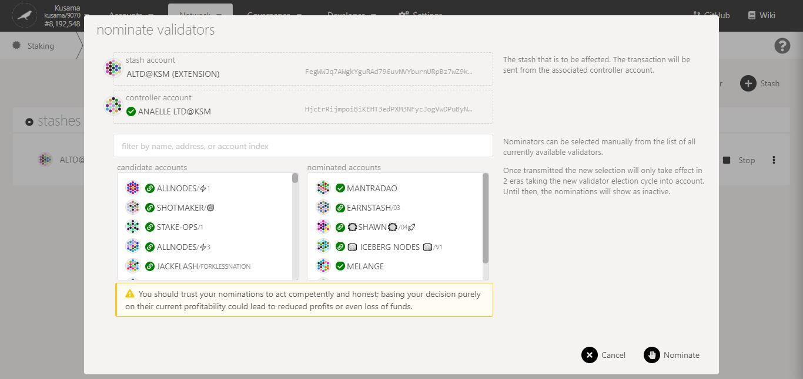

7. Click on **Nominate** to continue the procedure.

6. Double-check your **selection of validators.**

**Nature** of the transaction.

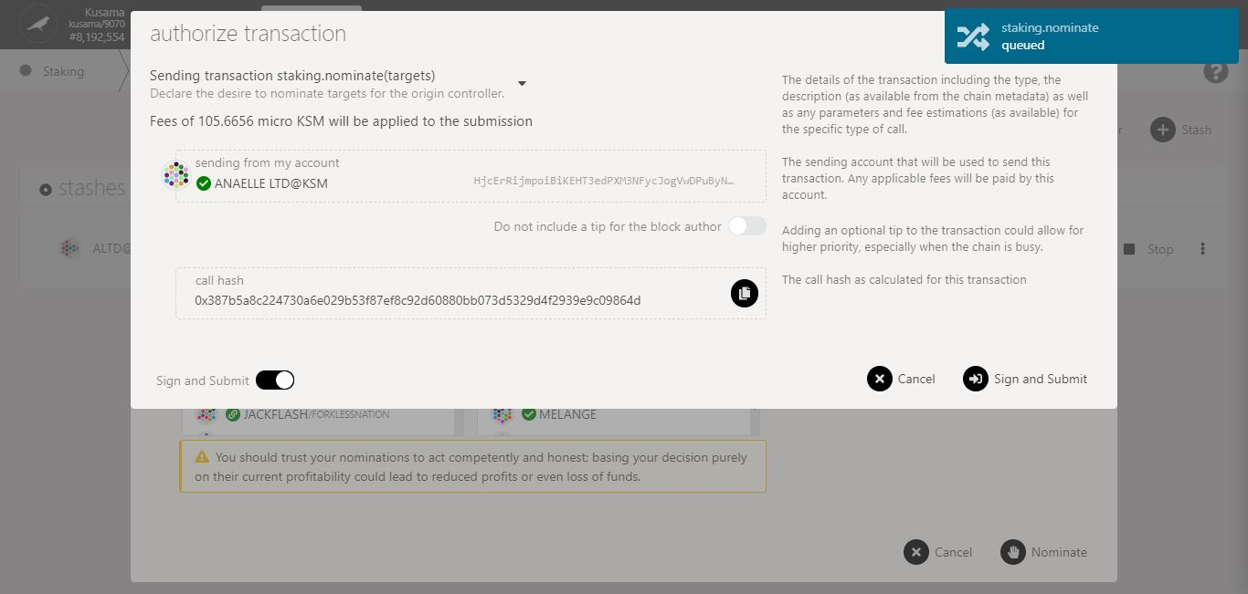

8. Check the **transaction fees**.

9. Click on **Sign & submit** to continue the procedure.

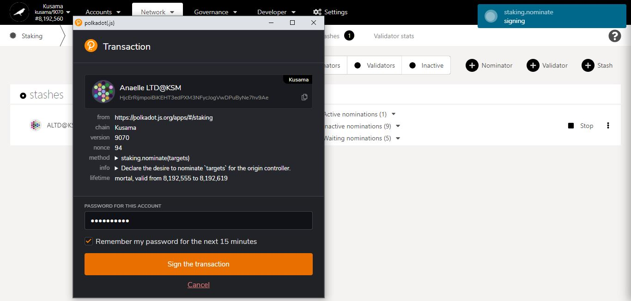

**Summary** of the transaction sent via the Polkadot-JS extension.

11. Click on **Sign the transaction** to complete the procedure.

10. Enter **your account’s password** and tick the box to **remember your password, if necessary**.

**Progress** of the transaction.

* 1. **Check payouts from recent eras.**

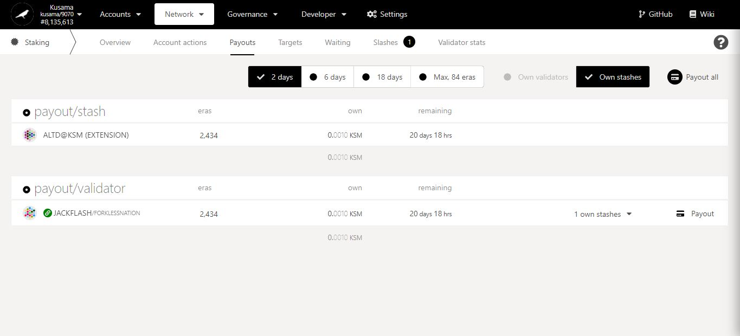

2. Click on **Payout (all)** to immediately receive rewards from your validator(s).

1. Click **Payouts**.

Time left for validators to **send the reward payouts**. Note: Most validators will send the reward payouts within a day.

Track all **rewards received and pending** for each individual era.

* 1. **Manage pools information:**
* **View pools.**

1. Click **Pools**.

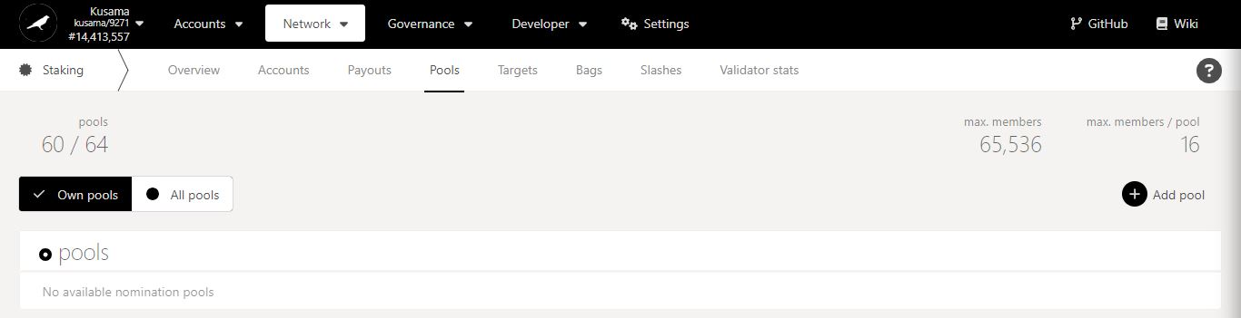

Nomination pools in details:

Nomination pools allow people to bond their funds together under a single entity called “pool”. There are different roles that members can observe within a pool.

**Creator**: The initial member who paid the pool deposit and must be last to leave the pool.

**Nominator:** The member who picks pool validators.

**Toggler:** The member who opens, blocks, or destroys the pool.

**Root:** The member who can change/override certain roles within the pool.

Note: Funds that are bonded in a pool cannot be used to vote during referenda or to elect councillors. Pool members need to unbond and unlock their stake before they can switch pools.

Key information on pools: Maximum number of pools, maximum numbers of members, maximum number of members per pool.

2. Check your own existing pools.

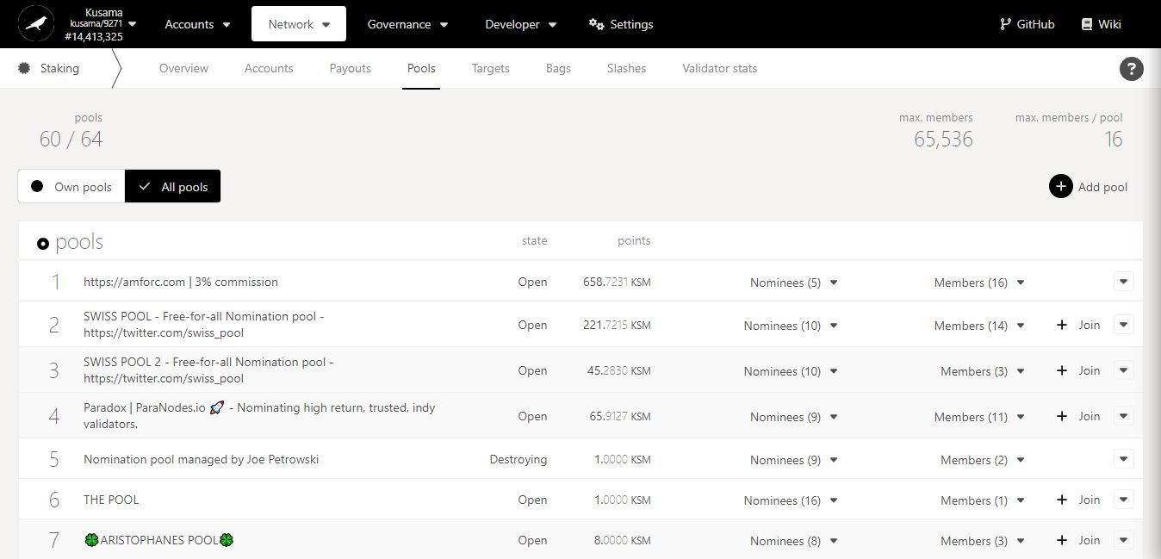

Number of validators selected by the pool.

Number of people in the pool.

3. Click **All Pools** to view all the pools registered on the network.

Pool funds

Pool status

Pool ID

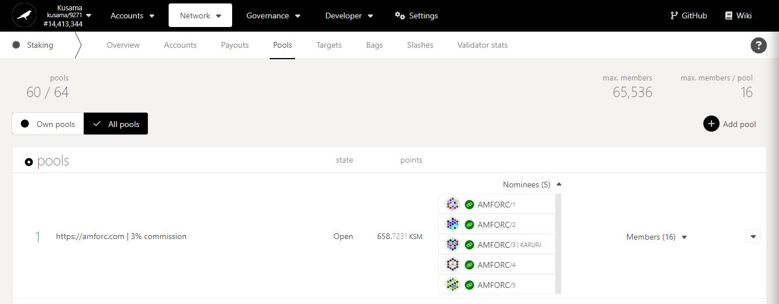

4. Click **Nominees** to view all the validators selected by the pool.

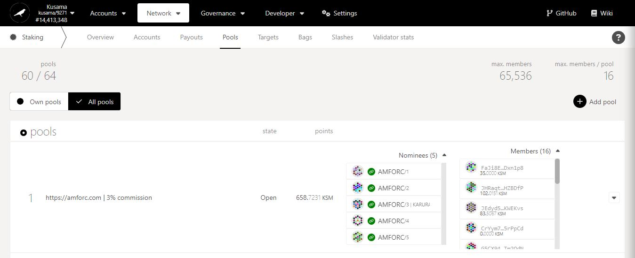

5. Click **Members** to view all the people in the pool and their bonded funds.

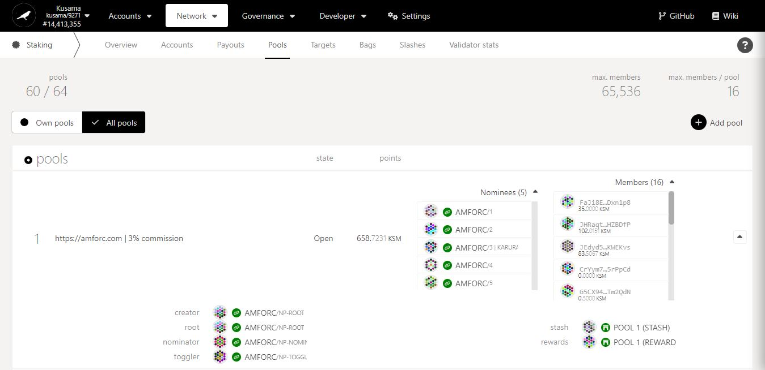

6. Click on **the arrow** to view all pool administrators.

* **Bond funds and join pools.**

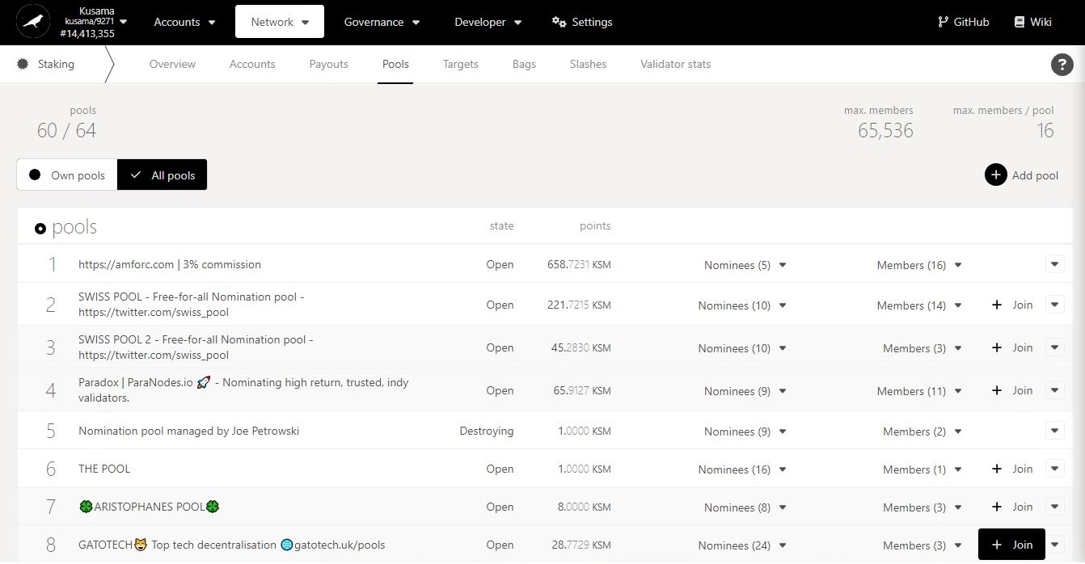

1. Click **Join**.

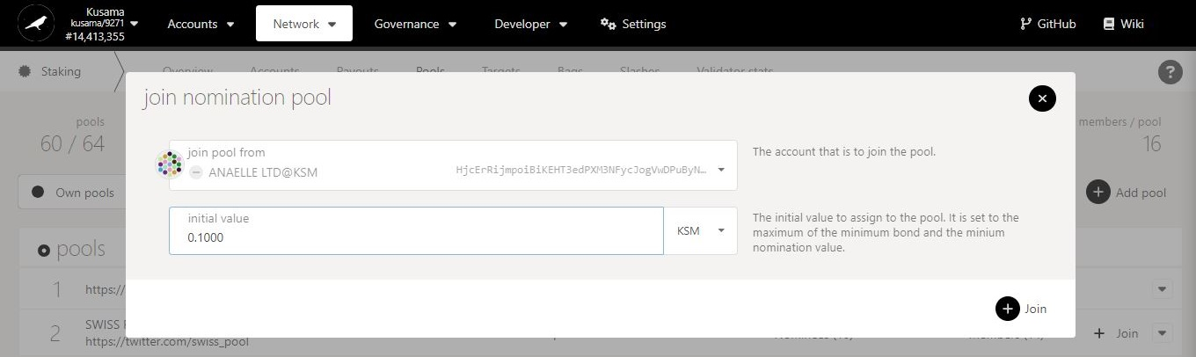

3. Click on **Join** to continue the procedure.

2. Follow **on-screen instructions** carefully.

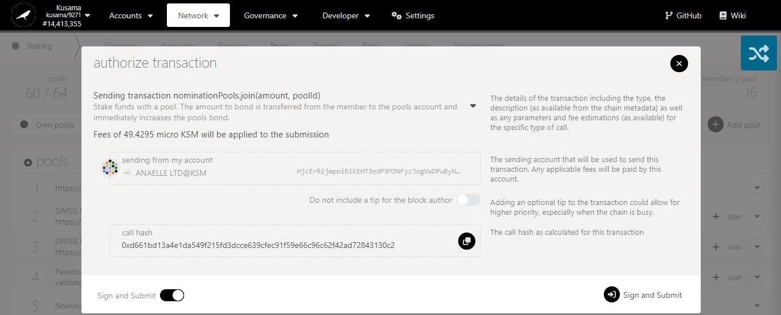

4. Check the **transaction fees**.

5. Click on **Sign & submit** to continue the procedure.

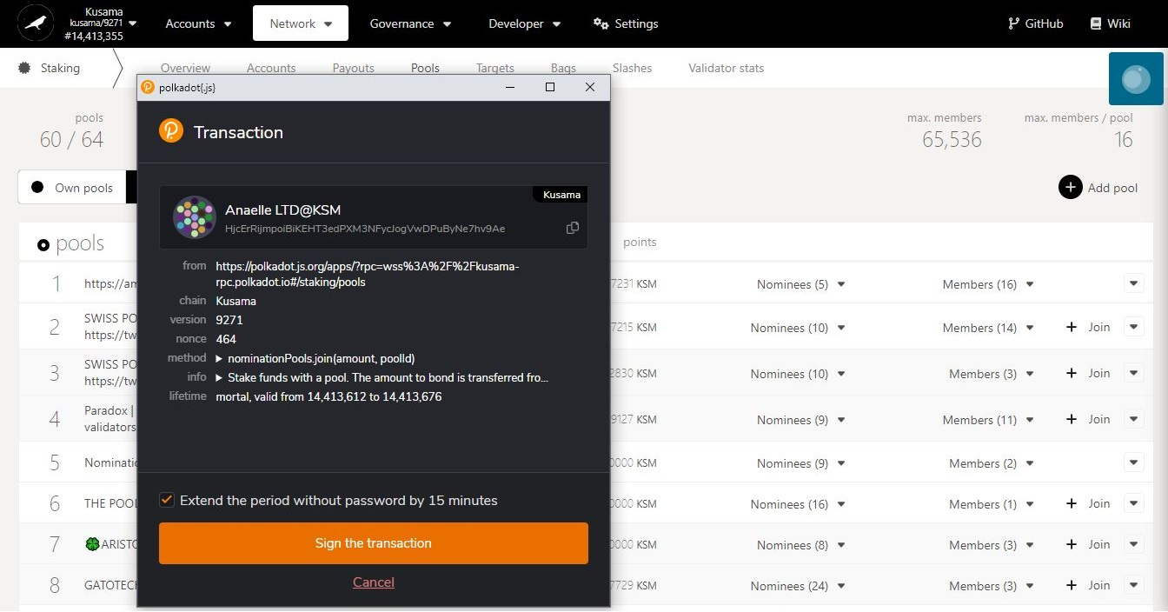

6. Click on **Sign the transaction** to complete the procedure.

**Summary** of the transaction sent via the Polkadot-JS extension.

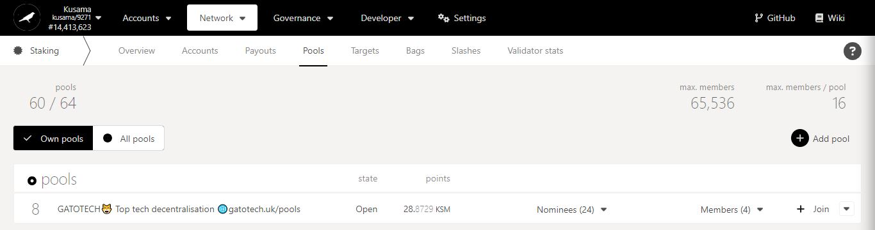

**7. The pool is now visible in your own pools!**

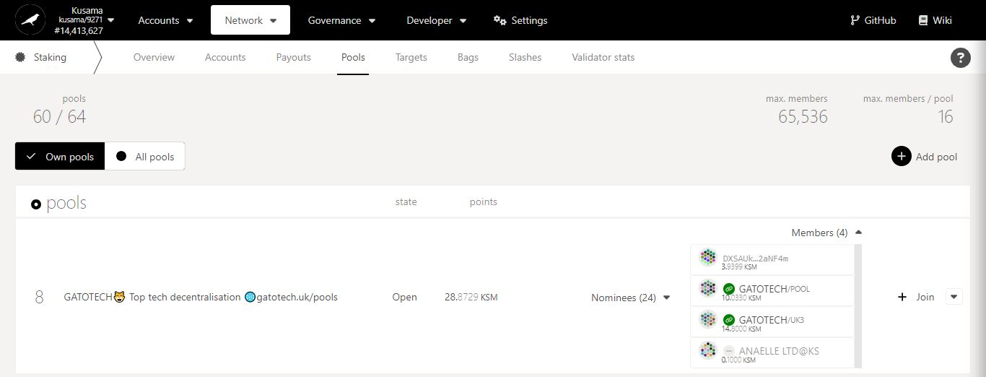

**8. Your account appears under the list of pool members!**

* **Unbond funds and leave pools.**

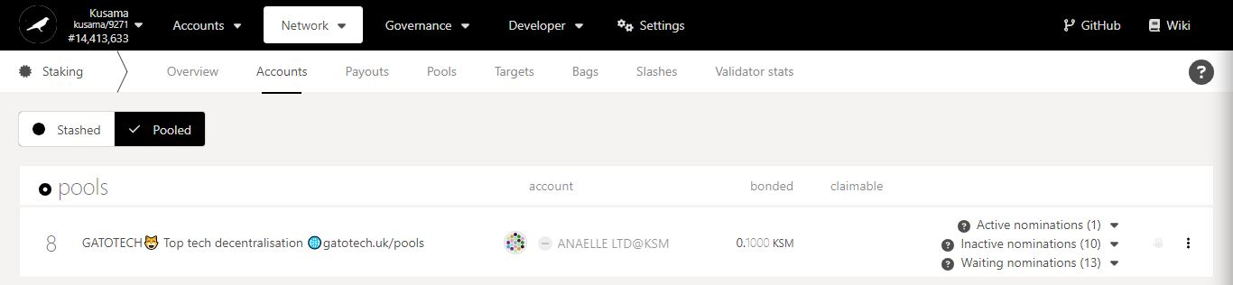

1. Click on the 3 vertical dots to view the **settings**.

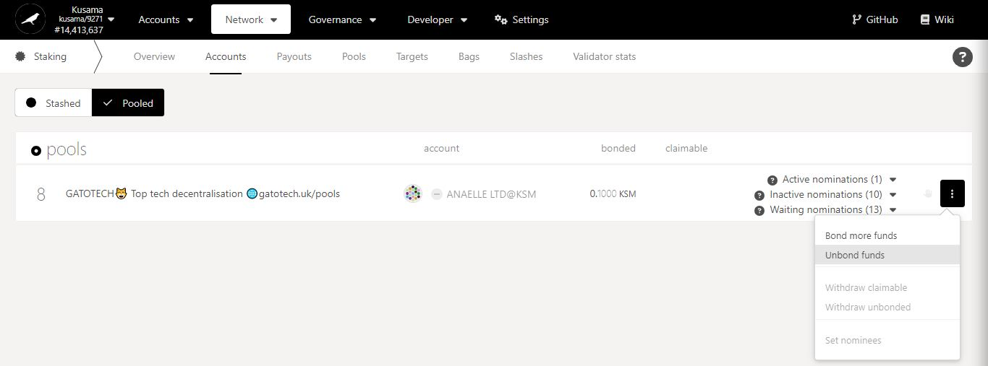

2. Click on **Unbond funds** to decrease the amount of KSM you are staking.

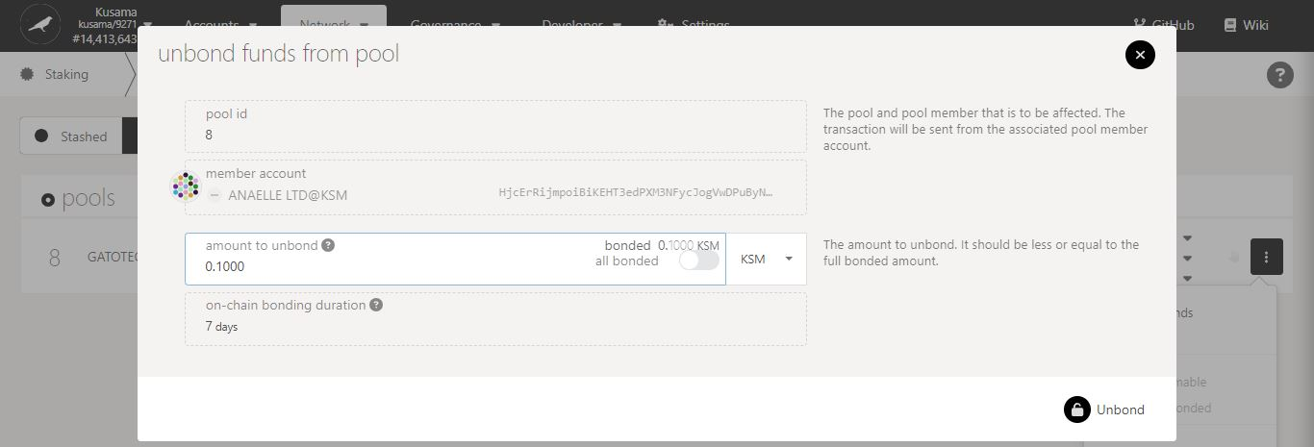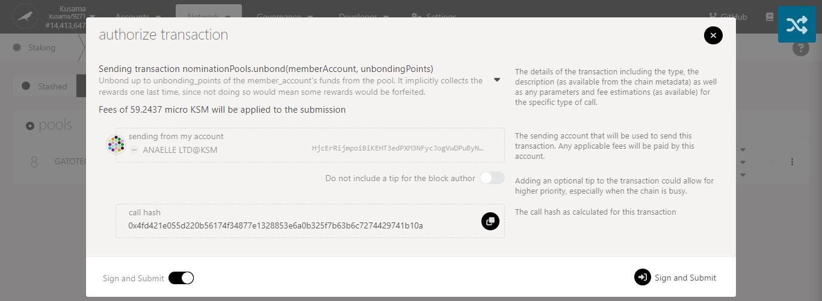

6. Click on **Sign & Submit** to continue the procedure.

5. Check the **transaction fees**.

4. Click on **Unbond** to continue the procedure.

3. Follow **on-screen instructions** carefully.

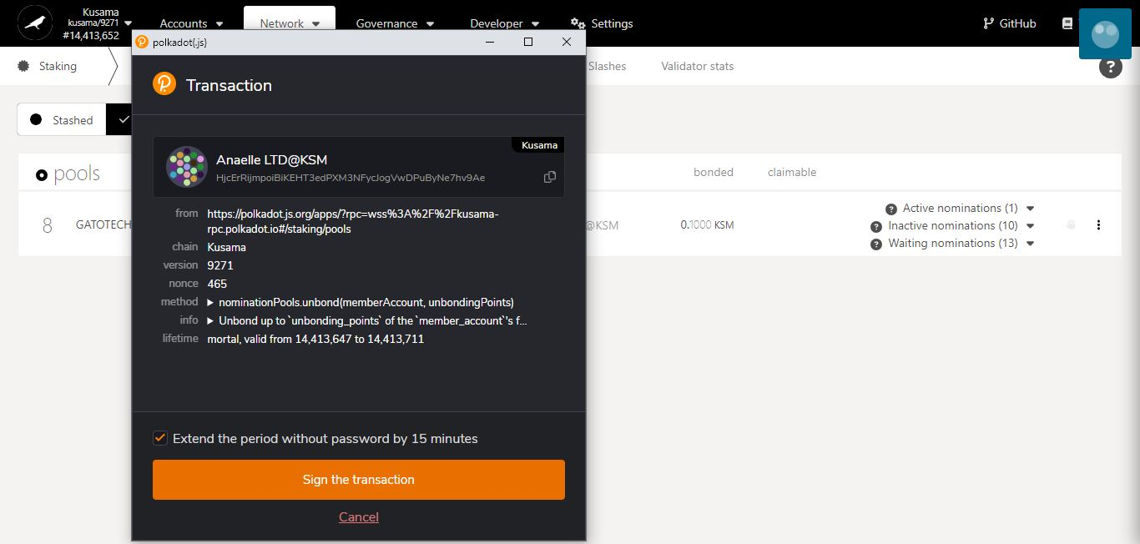

7. Click on **Sign the transaction** to complete the first part of the unbonding procedure.

**Summary** of the transaction sent via the Polkadot-JS extension.

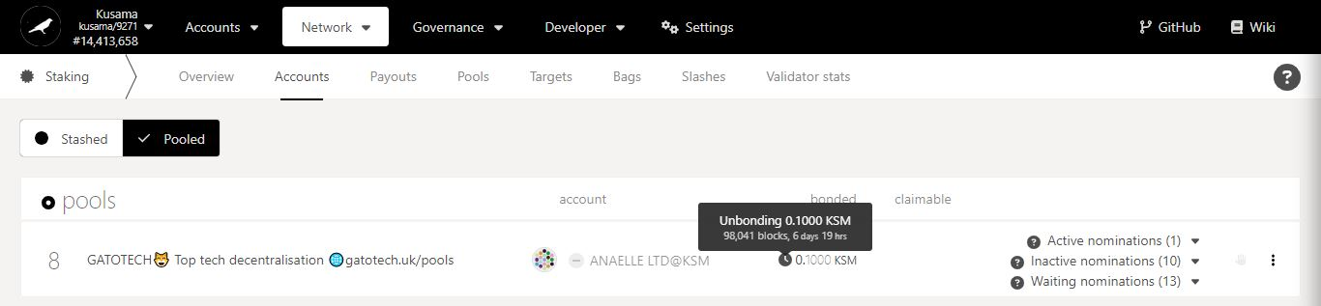

8. **Your funds have now entered an unbonding period!** **You will need to wait for 7 days before you can complete the procedure.**

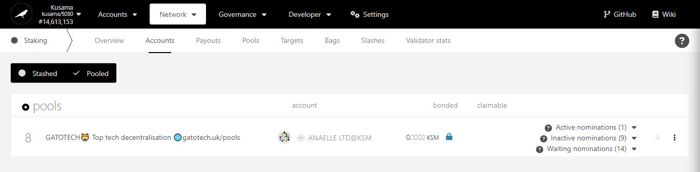

10. Click on the **padlock**.

9. **After 7 days,** you can resume the procedure.

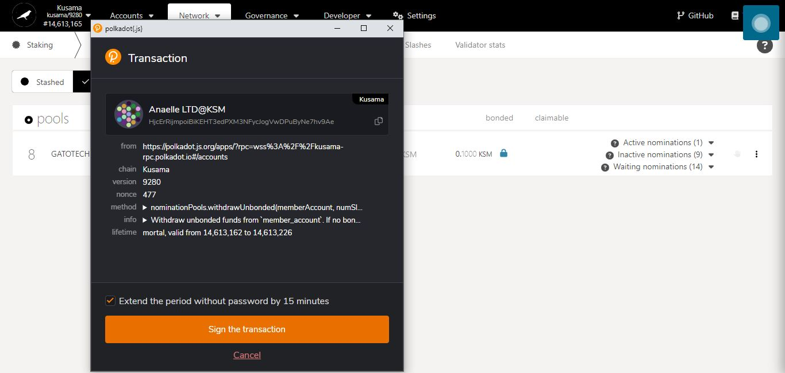

11. Click on **Sign the transaction** to complete the second part of the unbonding procedure.

**Summary** of the transaction sent via the Polkadot-JS extension.

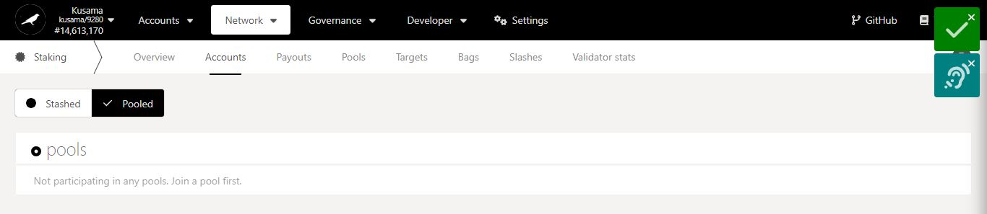

**12. Your funds have been released from the pool!**

* **Add pools.**

**[TBC]**

* **Remove pools.**

**[TBC]**

* 1. **Check nomination targets.**

1. Click **Targets**.

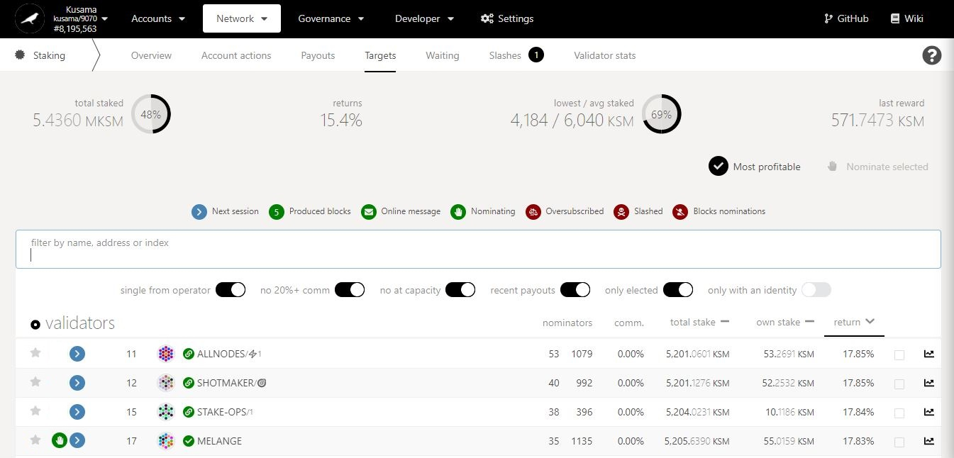

Key information on staking targets: **average returns, amount staked, and amounts rewarded.**

2. Switch the **filters ON** or **OFF** to display your **targeted data.** Ex: You can choose to view only validators who take <20% commission and are not full.

3. Scan through validators’ data and **compare it to your staking targets**.

This validator is in your **current selection of validators**.

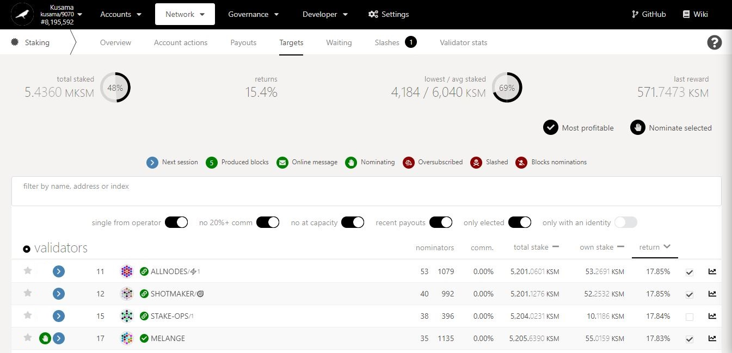

You can click **Most profitable** to **automatically select the top 16 rewarders**.

5. Click on **Nominate selected** to **replace your current list of validators** with a new selection. Note: If you do not select your current active validator, it will be removed!

4. Tick the box to select **10-16 validators that match** your staking targets.

* 1. **Check nomination bags:**
* **View bags**

1. Click **Bags**.

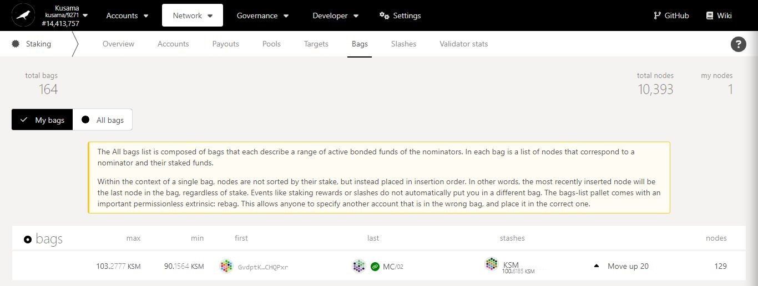

Key information on nomination bags (i.e semi-sorted lists of nominators within a particular stake range): **total numbers of bags, total number of nodes, and number of nodes linked to your stashes.**

First and last **inserted stashes/nodes** for this bag of nominations.

**Total number of stashes/nodes** inserted in this bag of nominations.

**Owned stash/node** inserted in this bag of nominations.

Maximum and minimum **bonded amounts** for this bag of nominations.

2. Check the information for your owned bags. **Bags**.

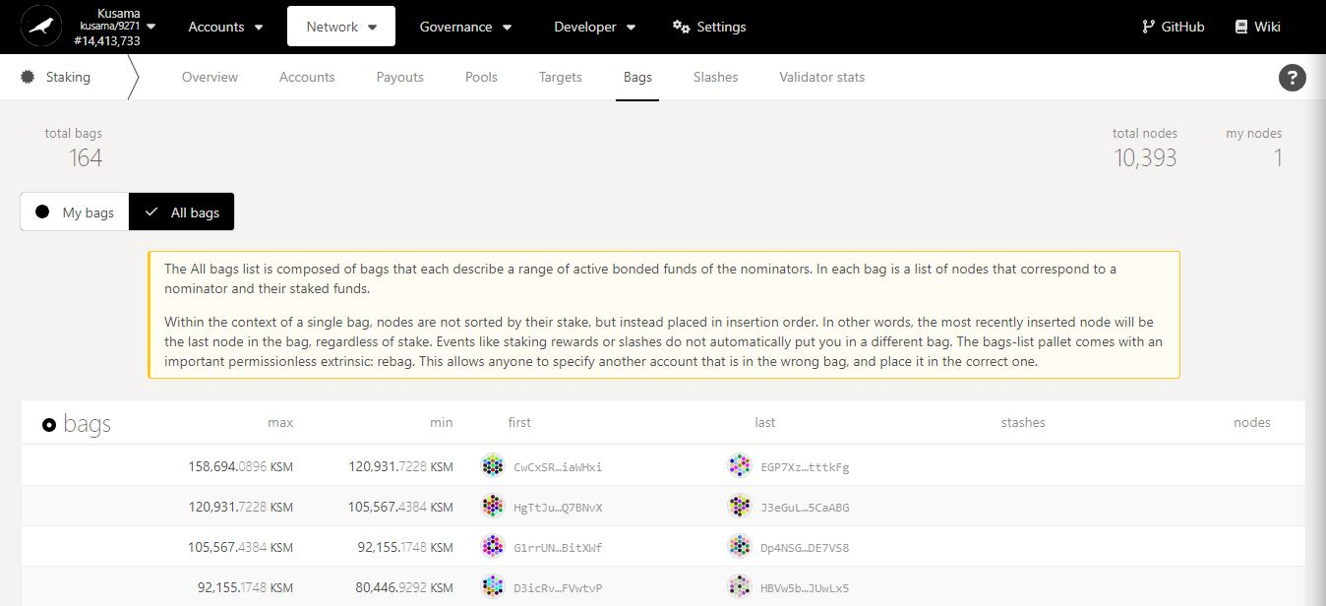

3. Click **All bags** to view the entire list of bags for the network.

4. Scroll down to find your bag in the list.

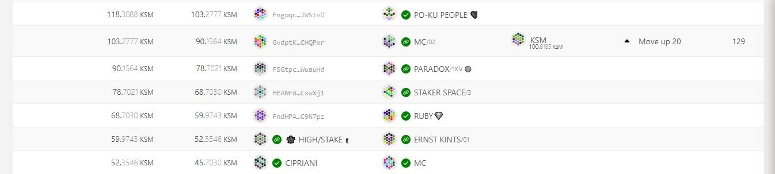

**5. You might get the option to move your node/stash up within the bag.**

* **Reposition bags**

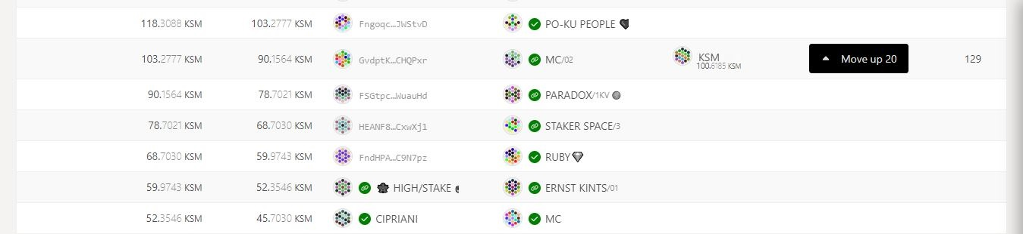

1. Click **Move up 20** to start repositioning your node/stash.

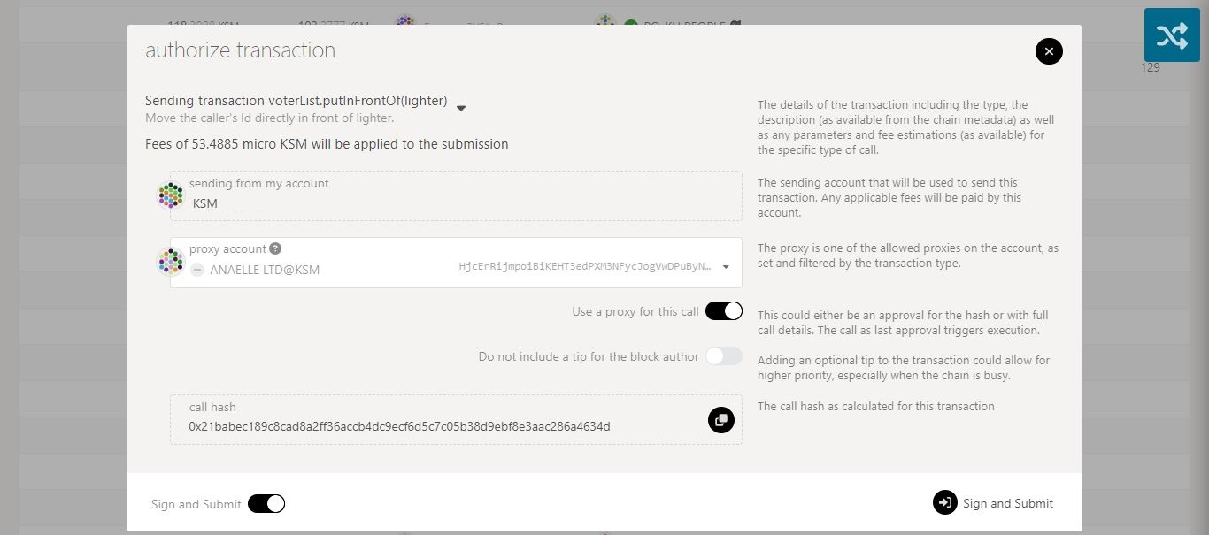

3. Click on **Sign & submit** to continue the procedure.

2. Check the **transaction fees**.

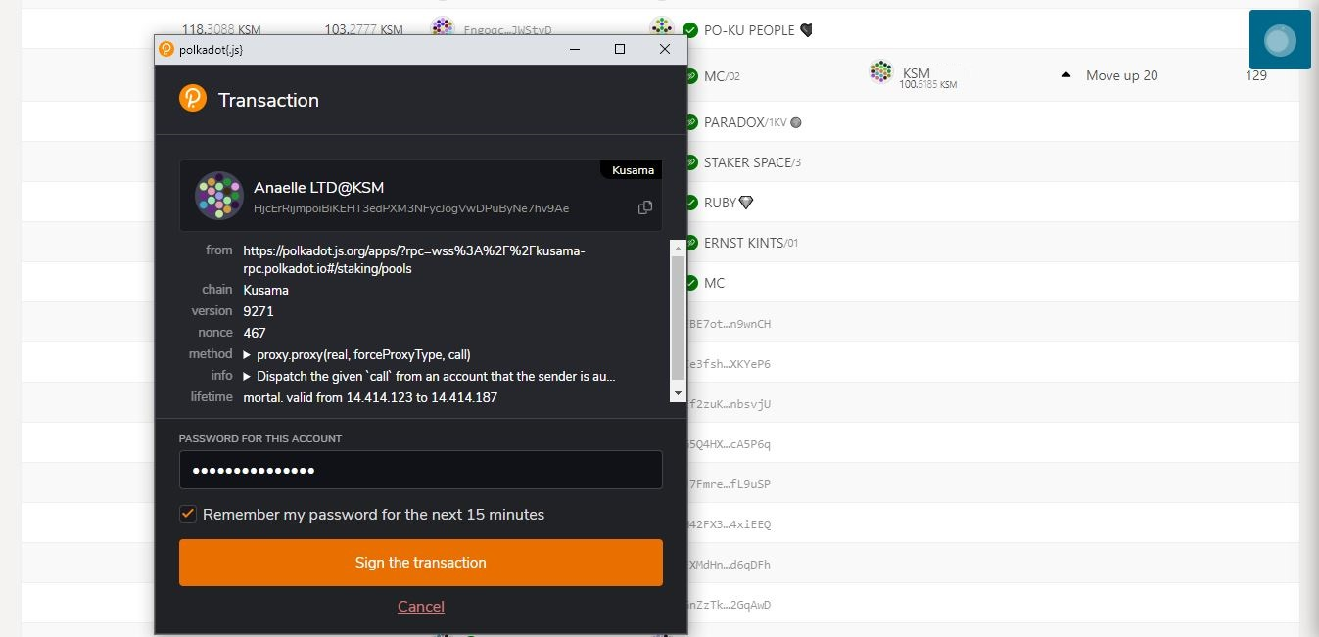

5. Click on **Sign the transaction** to complete the procedure.

**Summary** of the transaction sent via the Polkadot-JS extension.

4. Enter **your account’s password** and tick the box to **remember your password, if necessary**.

**6. Your position is now maintained or updated.**

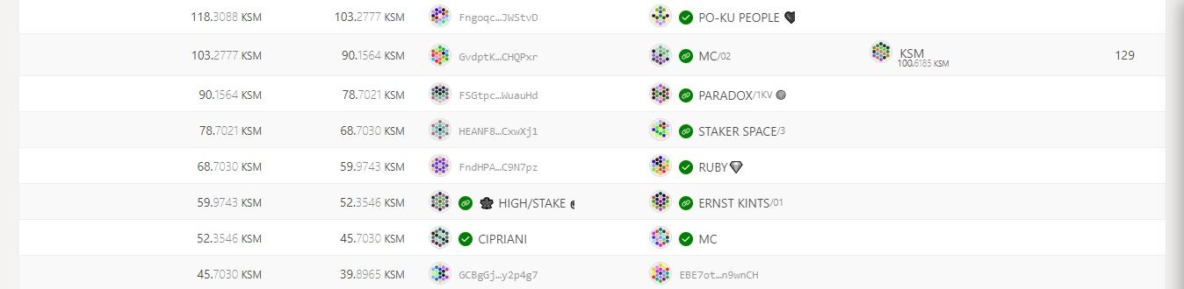

* 1. **Check the list of waiting validators.**

1. Click **Waiting**.

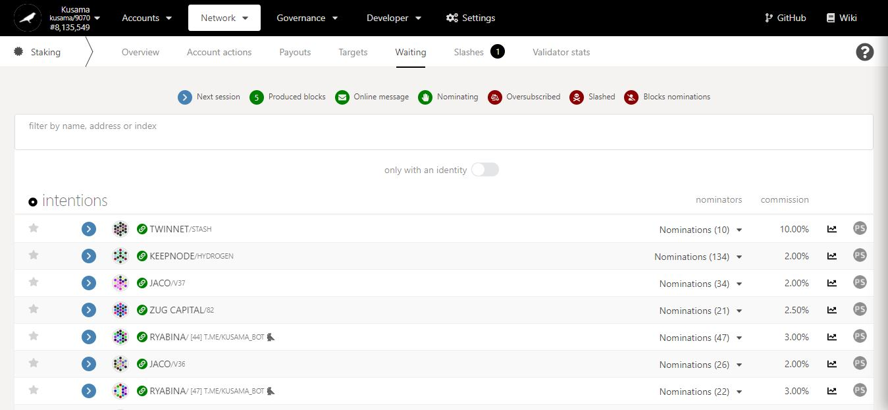

2. Click on **PS** to view a **validator’s statistics**.

Number of nominations **backing each unelected validator**.

* 1. **Check the list of slashed validators.**

1. Click **Slashes**.

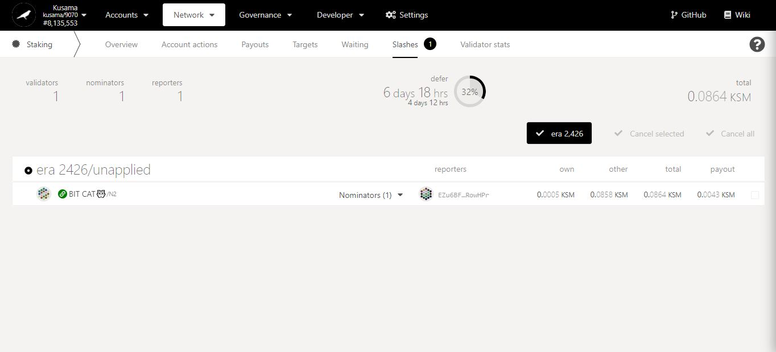

All amounts slashed are used to **fund the Treasury**.

Key information on staking slashes: **validators & nominators concerned, time frames, amount.**

2. Click on the slashed validator’s name to view **a summary of its account.**

3. Click on the dropdown arrow to view **slashed nominators’ information.**

* 1. **Check the statistics of individual validators.**

1. Click **Validator stats**.

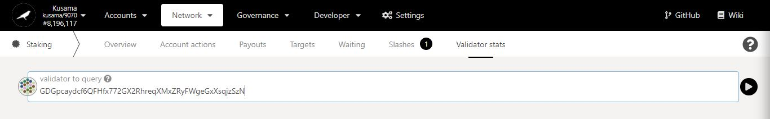

2. Enter/Paste the **address of a validator**, then click the **arrow** to view the validator’s information**.**

**Key validator history:**

- hourly points

- staking amounts

- election status

- rewards & slashes amounts

- commission %.

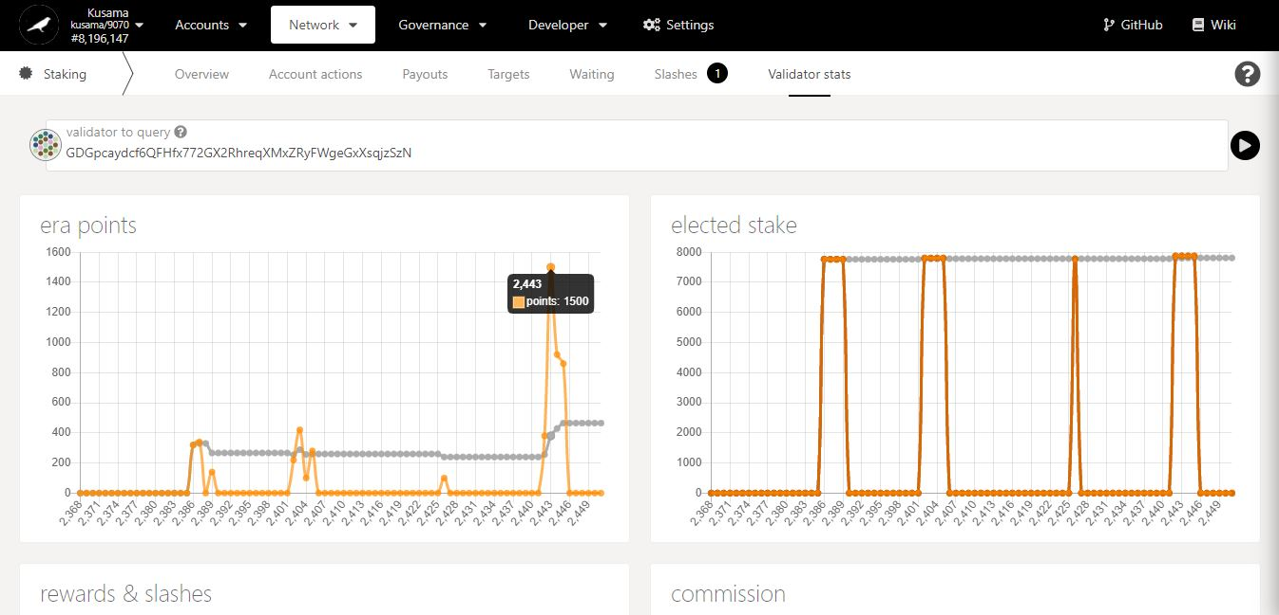

3. Move your mouse along the chart to get **detailed figures**.

1. **Parachains: Explore parachain-related activities.**



* 1. **View general parachain information.**

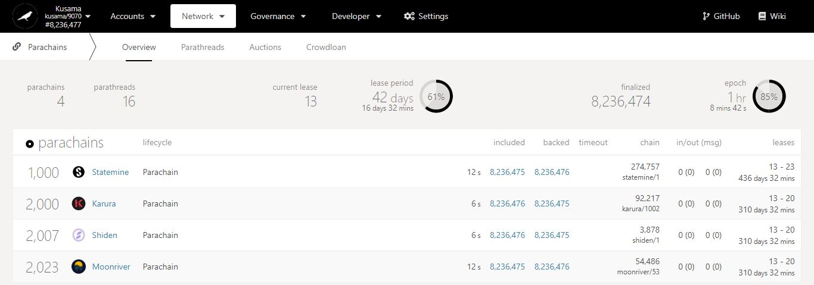

Key information on parachains: **waiting parathreads, current lease period’s ID, and lease period’s duration.**

Parachains summary:

- **Included:** Blocks produced by parachain collators.

- **Backed:** Blocks validated by relay chain (para)validators.

- **Chain:** Parachain runtime (chain spec) versions.

- **In/Out (msg):** Cross-chain messages sent/received by the parachain.

- **Leases:** Lease period IDs allocated to the parachain (when it obtained a slot) and their total duration (in days and minutes).

**Parachains** or **Parathreads**?

Registered **ParaIDs**.

Registered **names**.

* 1. **View onboarded parathreads.**

1. Click **Parathreads**.

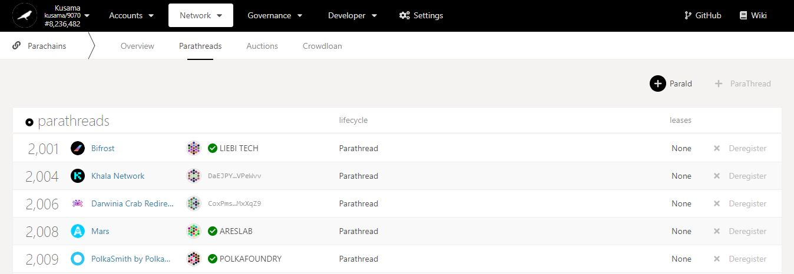

2. Click **ParaID** to register your network as a parathread.periods **obtained.**

Registered **names**.

**Parachains** or **Parathreads**?

Registered **ParaIDs**.

Leaseperiod IDs **obtained.**

Addresses of currently **registered parathreads**.

**NEVER SEND YOUR KSM TO A PARATHREAD’S ADDRESS!**

* 1. **View auctions’ progress.**

1. Click **Auctions**.

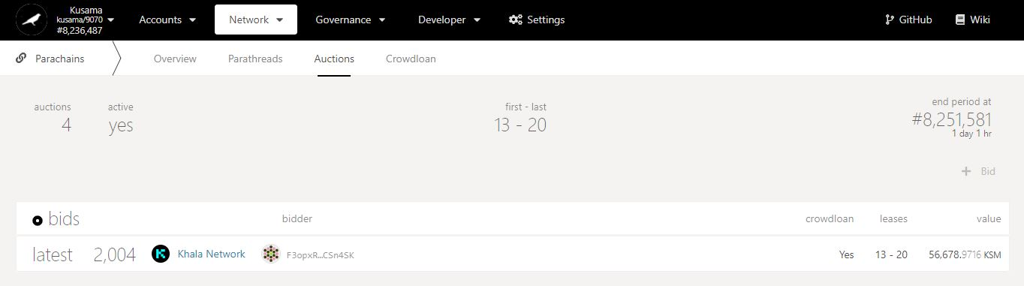

Countdown to auction’s end period (during which the winning bid will be determined).

Key information on auctions: **auction number, activity, lease period IDs, and timings.**

Is there a crowdloan campaign **associated to this bid**?

2. Check the latest bid(s) **included in recent blocks.**

**Targeted** leaseperiod IDs.

KSM amount **submitted for this bid.**

Addresse(s) of current **bidder(s)**.

**NEVER SEND YOUR KSM TO A BIDDER’S ADDRESS!**

* 1. **View and contribute to crowdloans.**

1. Click **Crowdloan**.

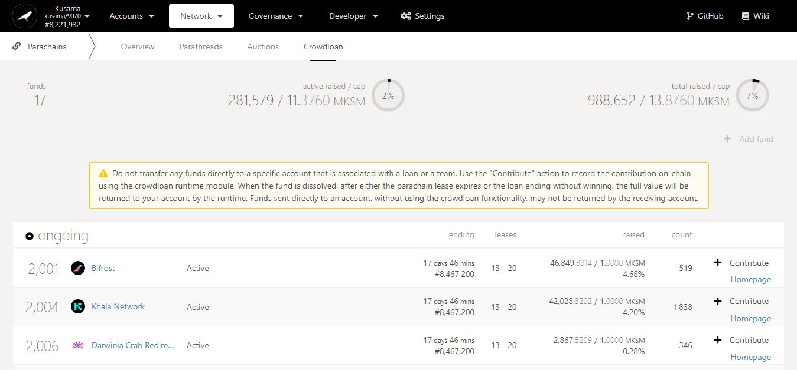

Time left **to fund a crowdloan** and **win an auction.**

2. Double-check **warning messages.**

Key information on crowdloans: **active funds, and KSM amount locked in funds.**

KSM amount raised by each fund **out of its total desired cap.**

3. Click **Contribute** to lend your KSM to a fund.

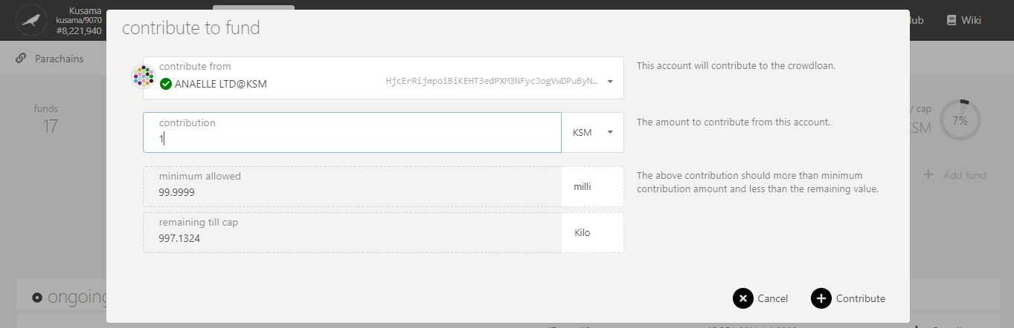

5. Click on **Contribute** to continue the procedure.

**Minimum** crowdloan contribution is **0.1 KSM**.

4. Follow **on-screen instructions** carefully.

**Nature** of the transaction.

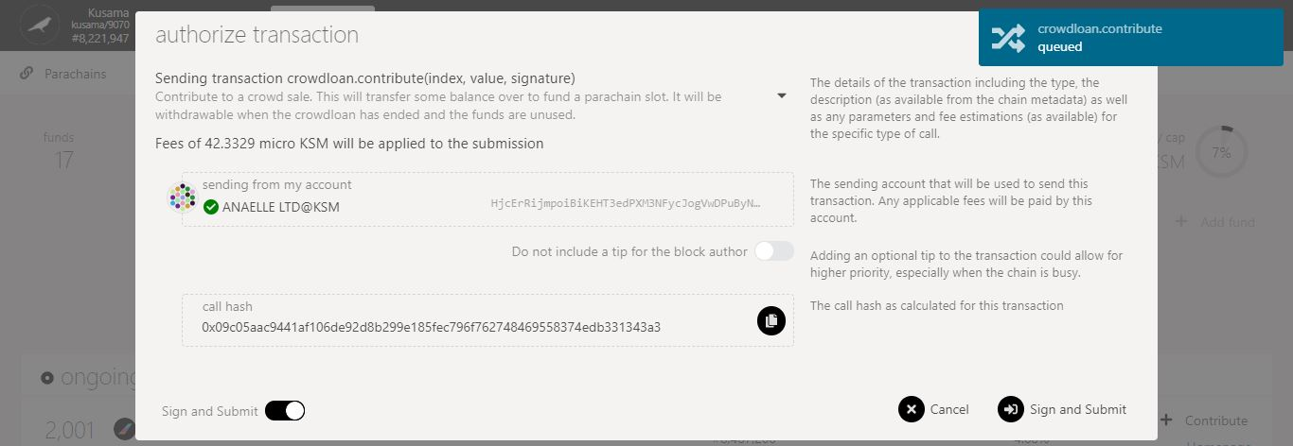

6. Check the **transaction fees**.

7. Click on **Sign & submit** to continue the procedure.

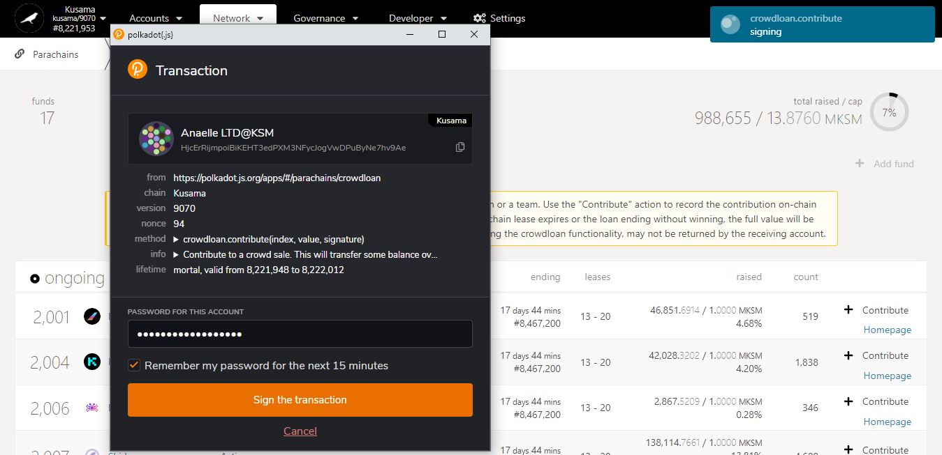

**Progress** of the transaction.

9. Click on **Sign the transaction** to complete the procedure.

**Summary** of the transaction sent via the Polkadot-JS extension.

8. Enter **your account’s password** and tick the box to **remember your password, if necessary**.

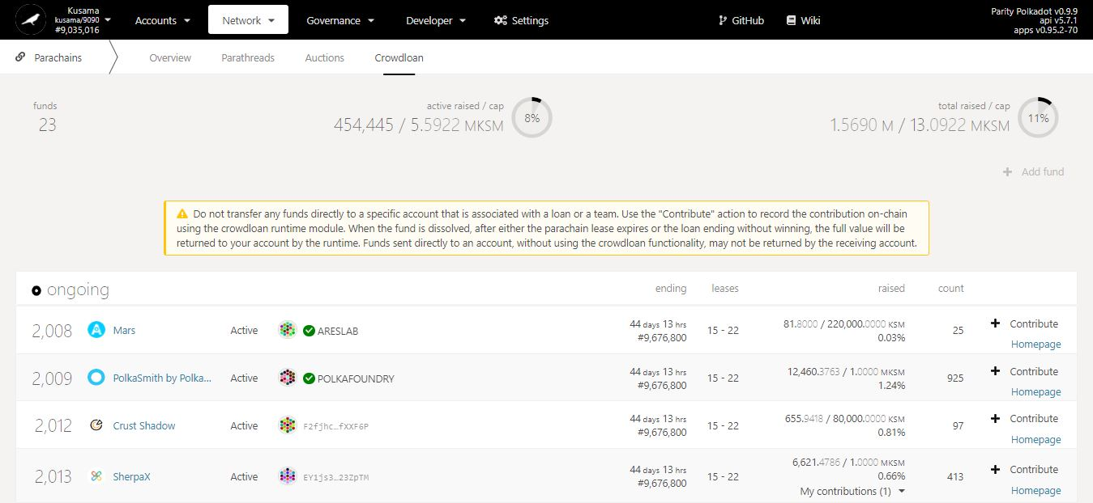

10. Click on the **dropdown arrow** to view your crowdloan contribution.

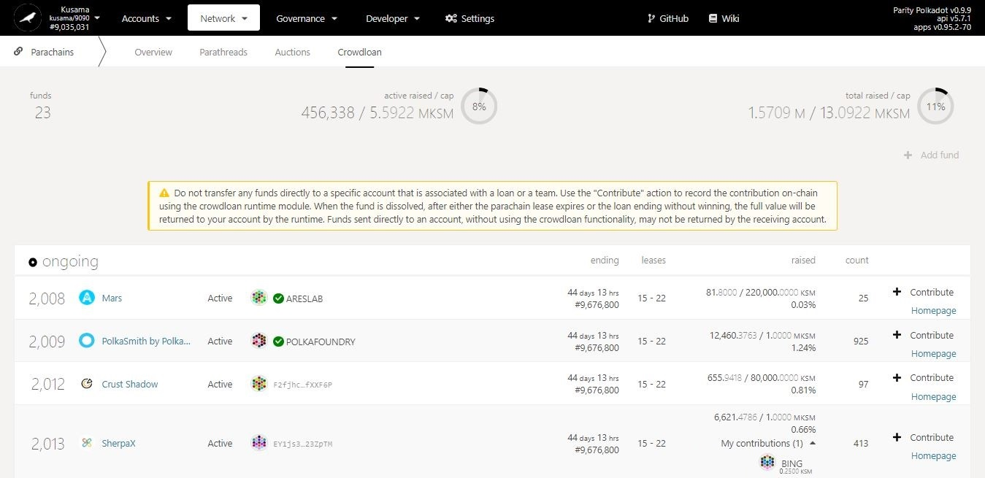

11. **Your contributing account and contribution amount are now visible!**

1. **Gilt: View and participate in auctions for inflation-protected KSM derivatives. [TBC]**



1. **Society: View and participate in *Kappa Sigma Mu* activities.**



* 1. **View Society members’ roles.**

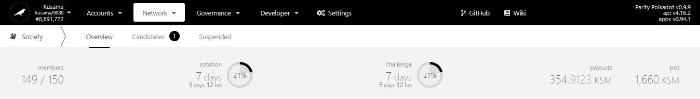

Key information on Society: **number of members, countdown to the change of members’ roles, time left for the completion of challenges, scheduled payouts to members, total value of Society’s pot.**

Society roles in details:

The Kappa Sigma Mu (KΣM) is a Kusama-native organisation created on 20th January 2020.

The Society has a set of pre-defined on-chain and off-chain rules for membership acquisition, role attribution, and challenge completion.

**Members:** Kusama blockchain users who have successfully been vetted by the Society.

**Candidate:** A user who has submitted a bid and Proof-of-Ink (PoI) to become a member and must receive approvals from the members to join the Society. Also known as “Member-candidate”.

**Defender:** A member who has submitted a Proof-of-Ink (PoI) and must receive approvals from the members to remain in the Society. Also known as “Challenged-member”.

**Society head:** A winning candidate chosen at random to become a Head. Also known as the “parent member”.

**Founder:** The anonymous user who founded the Society. Also known as the “original Head”.

**Skeptic:** A member who has been selected to vote by approving or rejecting a Candidate’s bid or a Defender’s PoI. Note: A no-vote equals to a rejection.



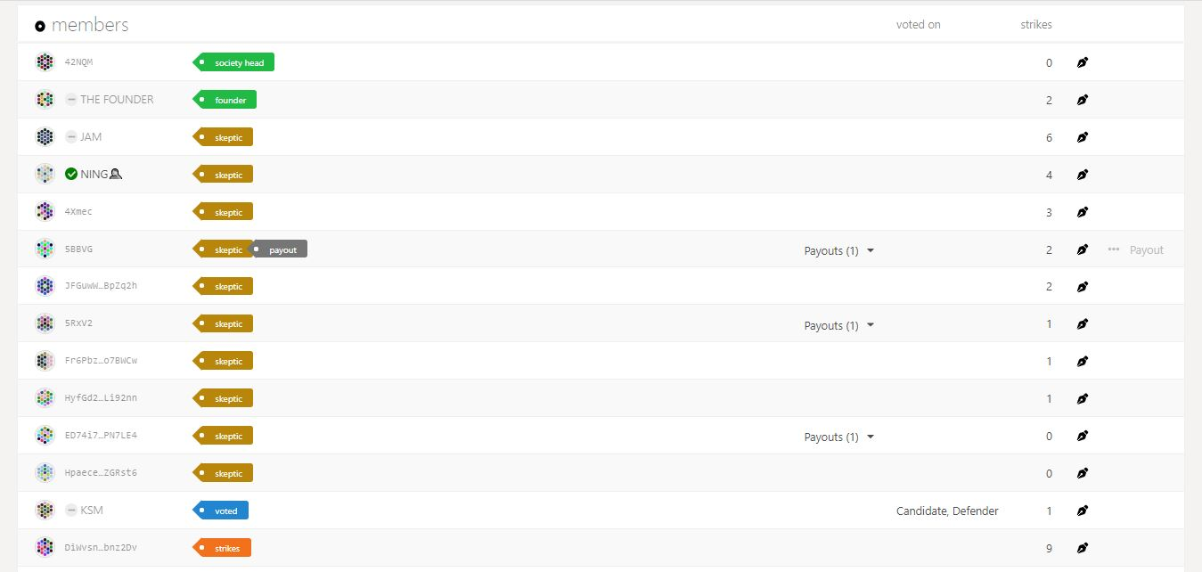

* 1. **View Society activities.**



Society activities in detail:

The Society has an extensive system of pre-defined tasks and feedback mechanisms to ensure that all members remain honest and engaged over time.

**Votes:** Approval or rejection of a Candidate’s bid or a Defender’s PoI. One of all members’ votes is randomly selected as the final vote on a Candidate or Defender.

**Strikes:** Punishment for failure to vote or for voting opposite to the randomly selected final vote. Note: The maximum number of strikes is 10.

**Payouts:** Reward for being a member of the Society that is based on the original bid amount. This amount is taken from the Society pot, which is funded by a 0.2% burn of Kusama Treasury. Note: Payouts need to be claimed manually.

**Slashes:** Punishment for voting opposite to the randomly selected final vote. This amount is taken from the opposing member’s pending payout and transferred as an escrowed reward to the approving member’s payout.

1. Click on the **dropdown arrow** to view the payout information.

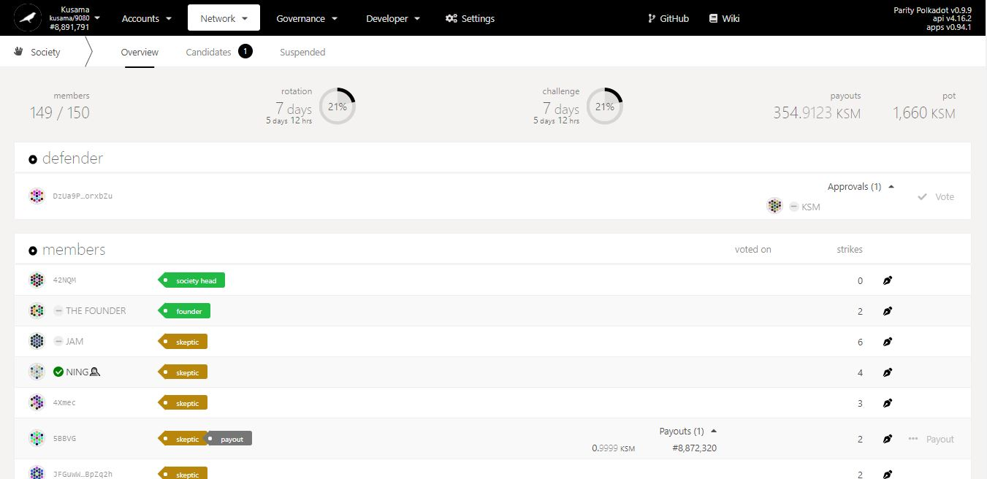

Block number at which the payout will be processed.

Amount to be paid.

**Proof-of-Ink:** Society members must provide a proof of membership on an ongoing basis by showing a picture of their Kusama tattoo that meets strict requirements (i.e permanent, over 2.54 cm in size, with an ID of the Kusama network and the current Society head).

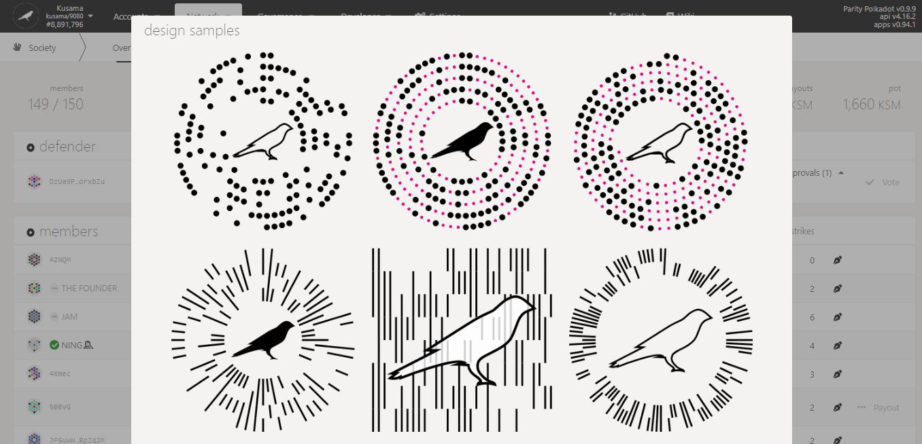

* 1. **View Society candidates, candidacy status, and bid kinds.**



1. Click on **Candidates**.

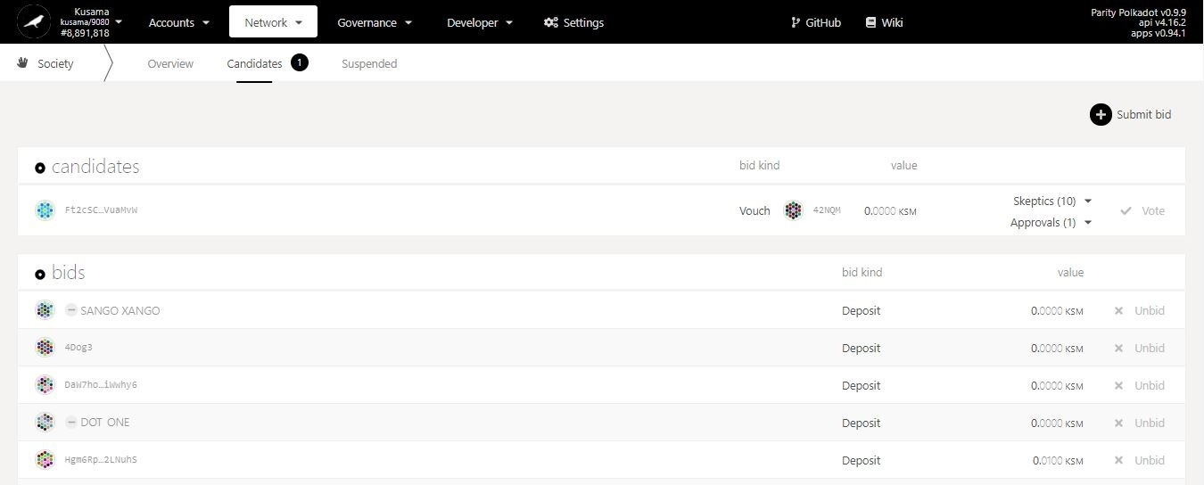

2. **The list of successful bidders and queued bidders is now displayed!**

3. Click on the **dropdown arrow** to see the list of Skeptics who have cast their vote.

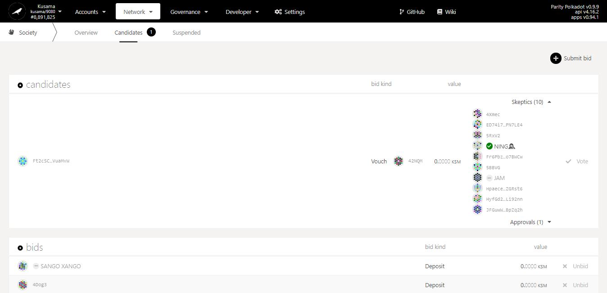

4. Click on the **dropdown arrow** to see who voted for an approval or a rejection.

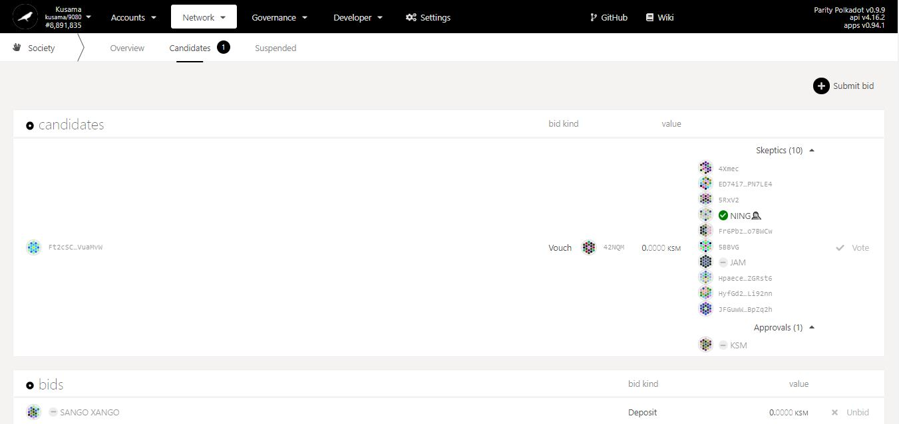

Information about the bid kind.

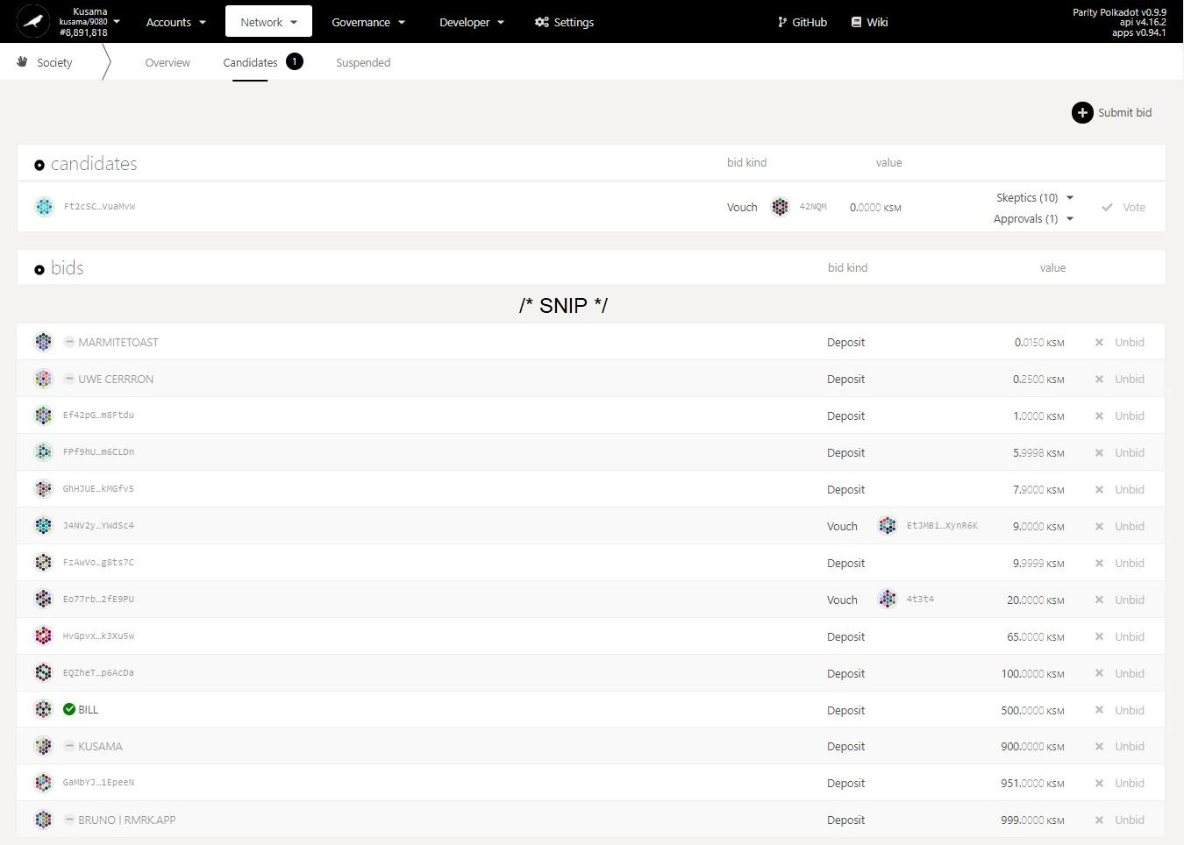

Bid kinds in detail:

To join the Society, users can either proceed independently or get an existing member to endorse their bid.

Bids represent the amounts that users would like to get as a payout from the Society pot. Successful bidders are promoted as Candidates. Note: The maximum number of successful bidders per rotation period is 10.

**Deposit:** When a user submits a bid by him/herself.

**Vouch:** When a member submits a bid on behalf on a user and earns a tip for it.

* 1. **Submit a candidacy bid via deposit.**



1. Click on **Submit bid**.

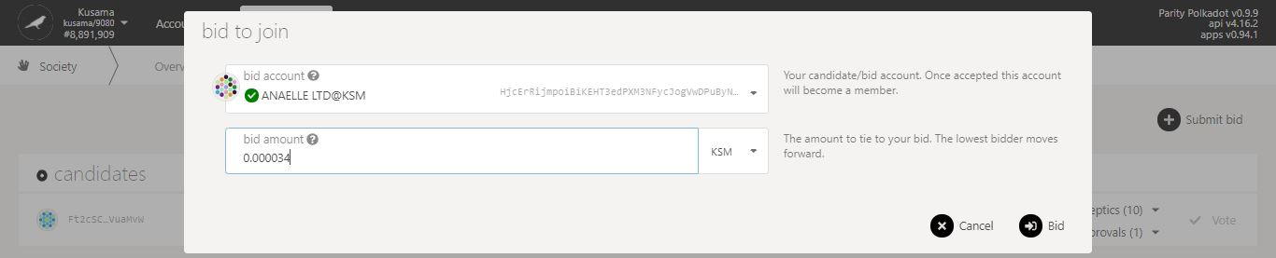

4. Click on **Bid**.

3. Enter a KSM amount **for your bid.**

2. Follow **on-screen instructions** carefully.

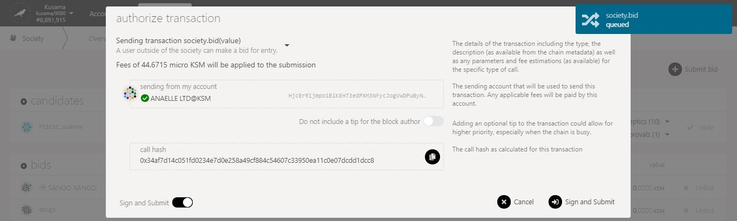

6. Click on **Sign & submit** to continue the procedure.

5. Check the **transaction fees**.

**Nature** of the transaction.

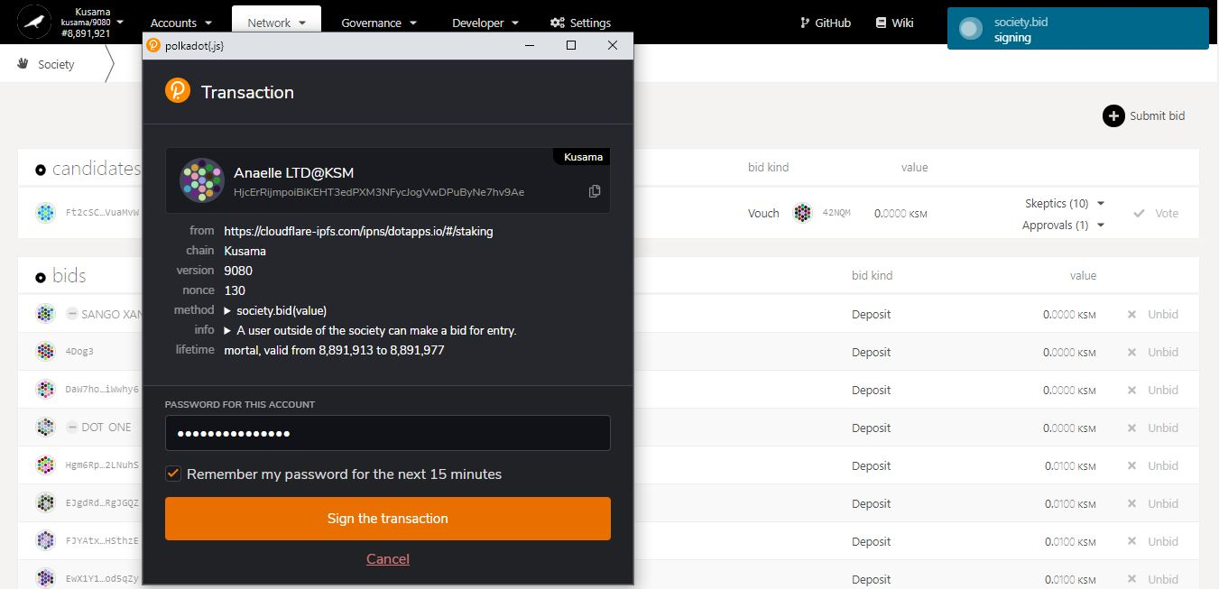

**Summary** of the transaction sent via the Polkadot-JS extension.

8. Click on **Sign the transaction** to complete the procedure.

7. Enter **your account’s password** and tick the box to **remember your password, if necessary**.

**Progress** of the transaction.

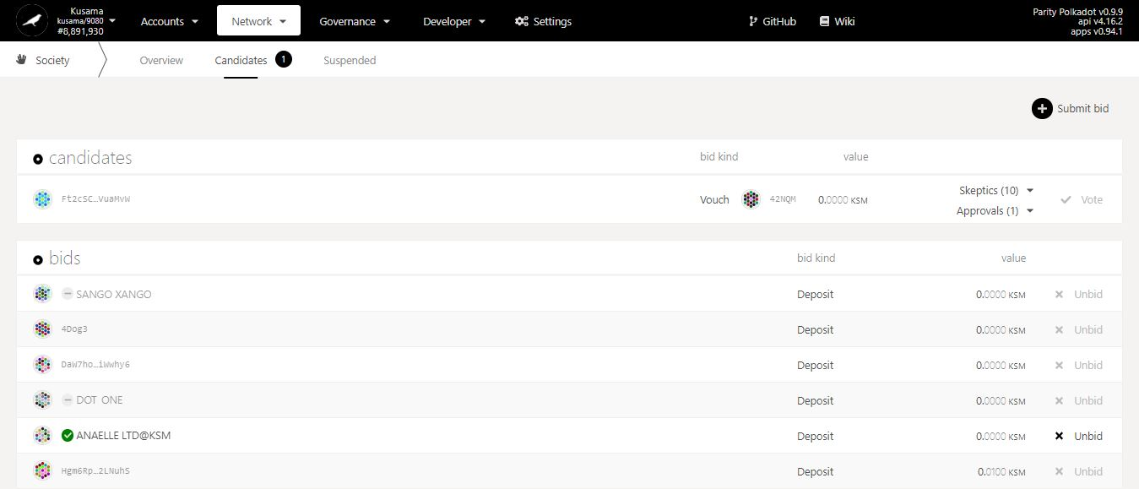

9. **Your bid is now in the queue!**

* 1. **Withdraw a candidacy bid.**

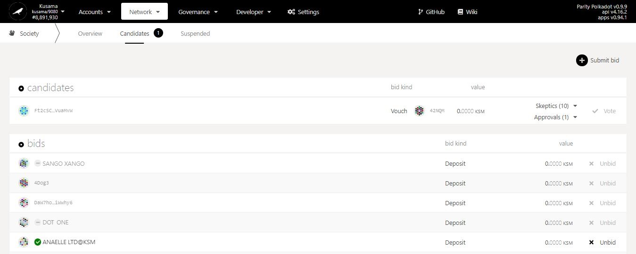

1. Click on **Unbid**.

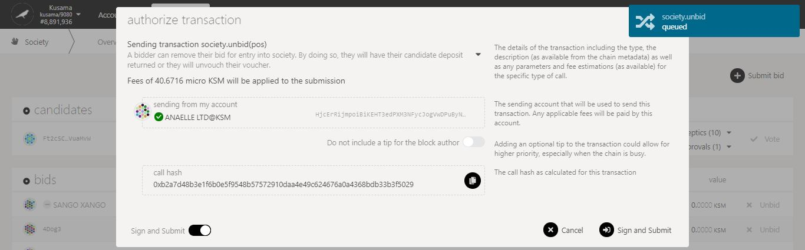

3. Click on **Sign & submit** to continue the procedure.

2. Check the **transaction fees**.

**Nature** of the transaction.

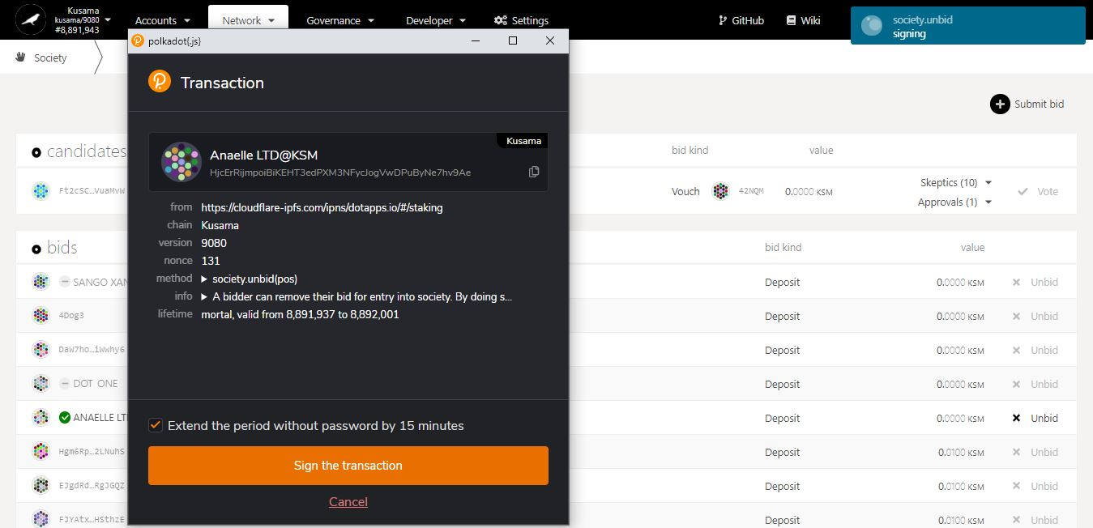

**Progress** of the transaction.

4. Click on **Sign the transaction** to complete the procedure.

**Summary** of the transaction sent via the Polkadot-JS extension.

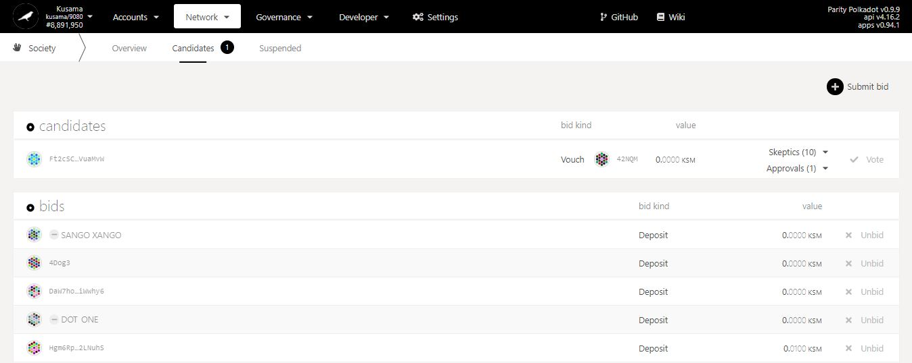

5. **Your bid has been removed from the queue!**

* 1. **Submit a candidacy bid via vouch.**

1. Mouse-over **Developer.**

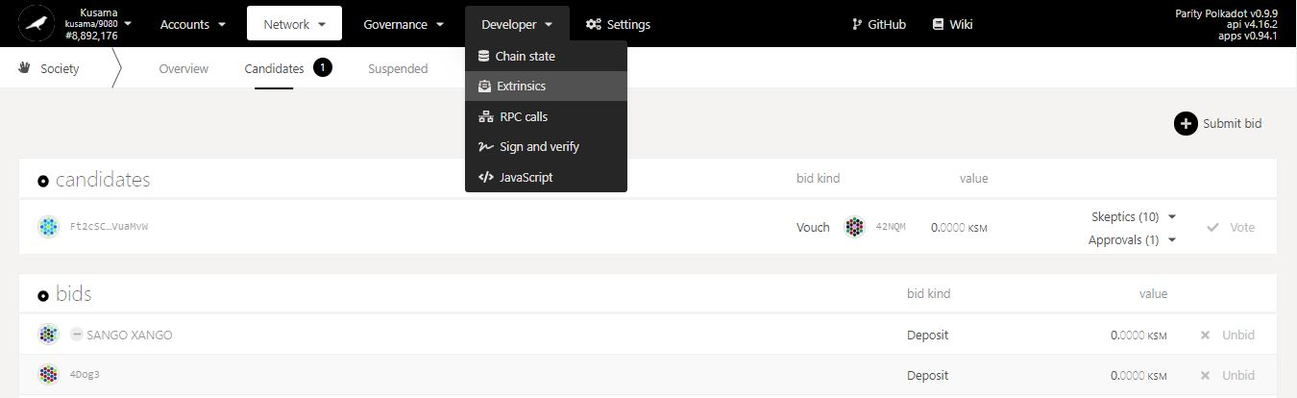

2. Select **Extrinsics** from the dropdown menu.

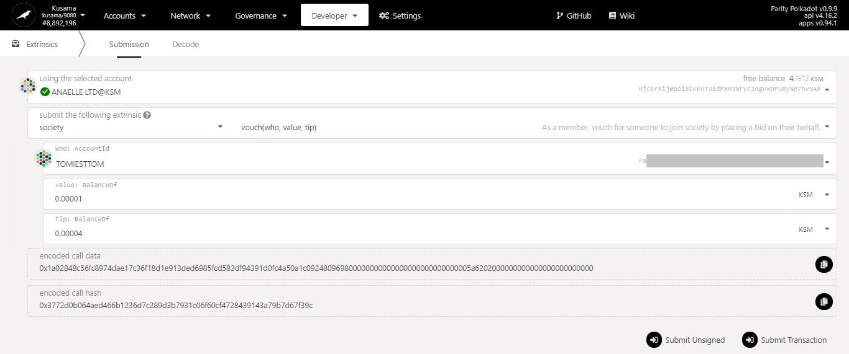

6. Enter a KSM amount **for the bid and the tip**.

5. Select the **account** of the bidder.

4. Navigate the **dropdown menus** to select the correct method.

3. Select the **account** of the voucher.

7. Click on **Submit Transaction**.

**Nature** of the transaction.

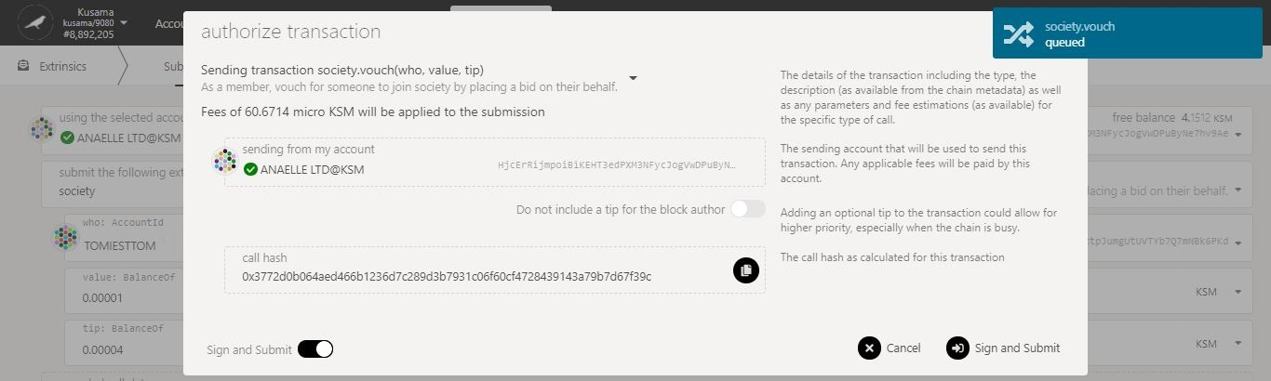

8. Check the **transaction fees**.

9. Click on **Sign & submit** to continue the procedure.

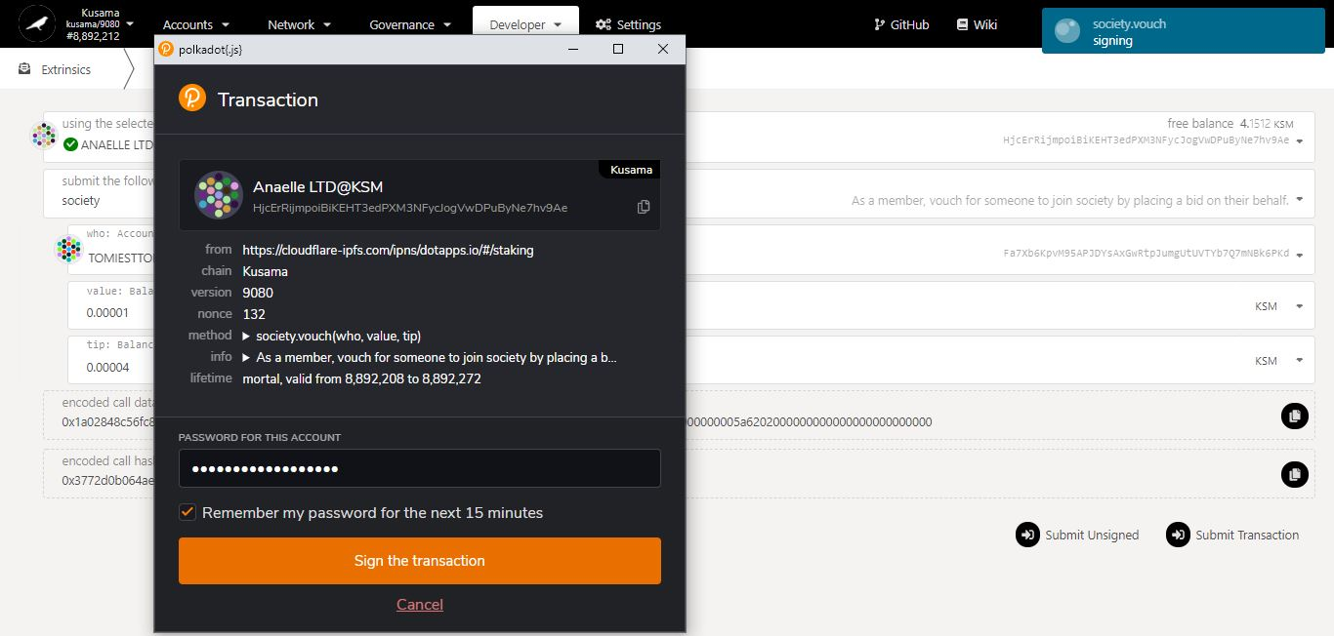

**Progress** of the transaction.

10. Click on **Sign the transaction** to complete the procedure.

**Summary** of the transaction sent via the Polkadot-JS extension.

* 1. **View suspended members and suspended candidates.**



1. Click on **Suspended**.

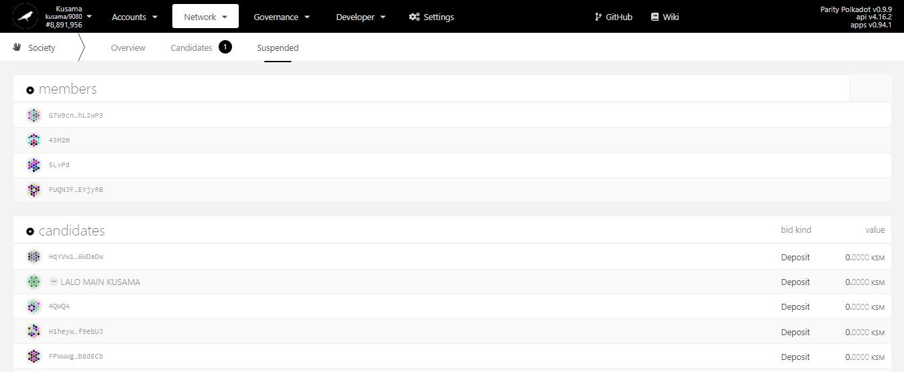

Suspension in detail:

**Suspended member:** A member that failed the Proof-of-Ink challenge or collected too many strikes. Note: Suspended members cannot claim their payouts and must be re-entered into the Society by the Founder to avoid losing all their future payouts.

**Suspended candidate:** A candidate that failed the vote. Note: Suspended candidates can be accepted as Society members, re-entered into the bid queue, or rejected by the Founder.

2. **The list suspended members and candidates is now displayed!**

1. **Event calendar: View upcoming Relay chain events.**



1. **Browse Relay chain schedules.**

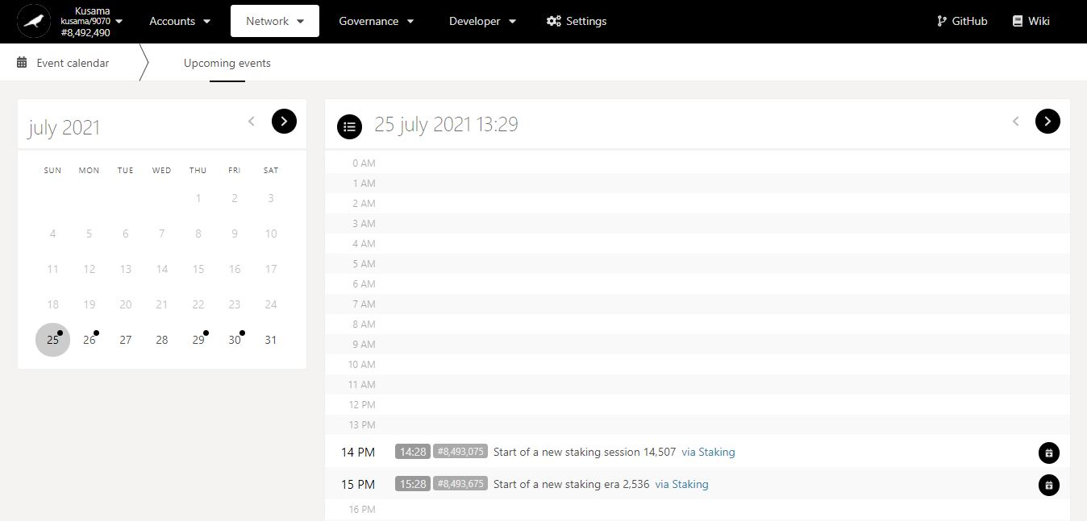

Click on a **day** to view its events.

Key information on upcoming events: **date, time, block number, description, and module.**

1. **Access core Relay chain modules.**

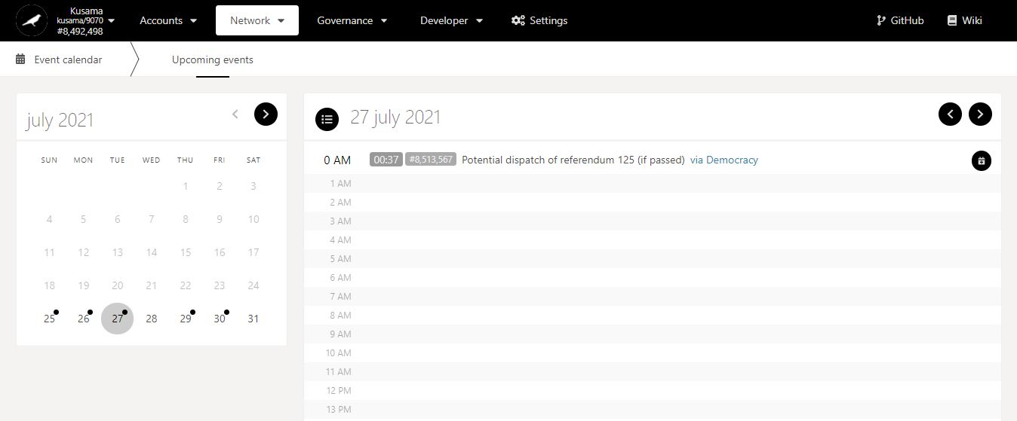

Click on the **module** to switch view on *Polkadot-JS Apps*.